**第二阶段rust for linux 作业说明**

本文档为第二阶段 rust for Linux作业的说明

在这份作业中，你将完成以下任务：

● 编译一次Linux内核

● 对Linux内核进行配置

● 使用rust编译一个内核模块

● 为一个rust的驱动模块编写一个函数

● 实现一个简单的rust驱动模块

祝您拥有一段顺利的cicv训练营之旅。

**课程相关资料**

上次训练营rust for linux阶段参考资料

<https://docs.qq.com/doc/DY2RVVFNoa3dxS2Vh>

本次训练营上课链接

<https://cicvedu.com/course/111>

本次训练营实验Classroom链接

<https://classroom.github.com/a/Fbbo8t3E>

**实验环境搭建**

**环境配置**

**~~docker使用~~（本次暂不提供docker环境，建议自行配置）**

**不使用docker自己配置环境**

您需要一个Linux系统，以便进行内核开发。可以在物理机上安装Linux，也可以使用虚拟机的形式。（如Windows下的WSL2，或者VirtualBox、VMWare）

关于Linux发行版，我们建议使用最新的Ubuntu LTS(目前是22.04)或Debian Stable(目前是12)，其它系统如Arch, Fedora等也可，但注意使用的包管理器和包名与Deb系的略有区别，需要自行解决。

以全新安装的Debian 12为例，注意以下配置需要root权限，请切换到root或使用sudo。

配置apt源，可参考<https://mirrors.tuna.tsinghua.edu.cn/help/debian/>

apt edit-sources

更新apt源：

apt update

安装git、curl等工具：

apt install git curl

安装rust工具链，一般使用官网推荐的sh脚本自动安装。

curl --proto '=https' --tlsv1.2 -sSf <https://sh.rustup.rs> | sh

Rust工具链服务器位于境外，如果安装时网速太慢，可以使用中科大提供的反向代理，使用说明可以参见<https://mirrors.ustc.edu.cn/help/rust-static.html>

安装编译相关工具、库等

apt install \  build-essential libtool texinfo \  gzip zip unzip patchutils \  cmake ninja-build automake bison flex gperf \  grep sed gawk bc \  zlib1g-dev libexpat1-dev libmpc-dev libncurses-dev \  libglib2.0-dev libfdt-dev libpixman-1-dev libelf-dev libssl-dev

以及安装Clang/LLVM

apt-get install clang-format clang-tidy clang-tools clang clangd libc++-dev libc++1 libc++abi-dev libc++abi1 libclang-dev libclang1 liblldb-dev libllvm-ocaml-dev libomp-dev libomp5 lld lldb llvm python3-clang

**代码仓库配置**

当配置好环境之后，还需要对代码仓库进行一定的修改。

**下载仓库**

首先，我们需要下载你的作业仓库~~到docker中，如果您不使用docker的方式~~，可以将该作业仓库放入任何您愿意放置的地方，但请注意接下来命令的绝对路径。

**配置git以便与github同步**

由于github现在不再支持使用https的方式对代码进行更改，仅仅可以下载，只支持git的方式，因此我们还需要在docker中生成密钥放入您的github中，如果您不使用docker，并且本地的Linux环境下已经有了相应的密钥和公钥并放入github中，那么请忽略接下来的配置密钥的步骤。

我们假定您已经有了一个github账号，如果没有请自行申请。

配置git使用的username和email，该信息将会在git提交记录中显示

git config --global user.name "Your username"

git config --global user.email "Your email@example.com"

请注意用你的github name和email填充

随后，生成ssh key，以便使用ssh连接至github

ssh-keygen -t rsa -C "Your email@example.com"

然后一直敲回车

随后

cat ~/.ssh/id_rsa.pub

将输出的公钥复制下来。

打开github.com，登录后点击右上角头像，从中找到Settings，在打开的页面中，找到左侧“SSH and GPG keys”选项卡，点击 New SSH key

将复制下来的内容黏贴到Key框内，并在Title里面给该密钥按照您的喜好取名。

最后点击Add SSH key即可。

您可以在docker或者命令行中使用

ssh -T git@github.com

进行测试，如果输出

Hi,"Your name"！You've successfully authenticated!...

等内容，则说明成功配置了密钥。

随后，点击本文档上方课程相关资料中的Classroom链接。并点击Accept该邀请，Classroom会自动在你的账号下生成作业仓库，这和Rustlings仓库中的操作基本一致。

查看你的作业仓库，并记下SSH访问的地址，如下图：

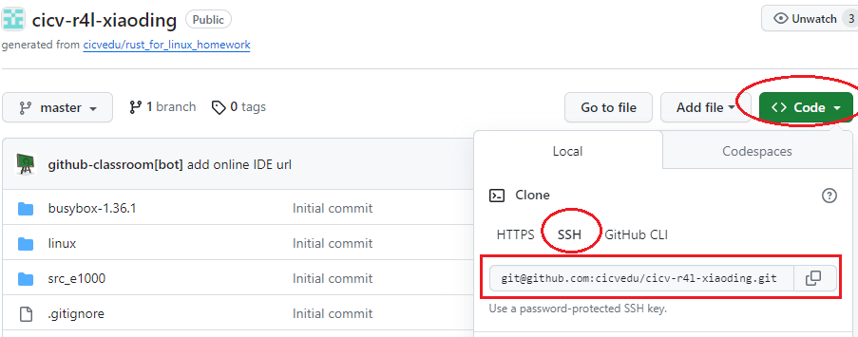

随后，使用git将远程仓库克隆到本地

#注意下面的xxxx应为自己的github账号名

git clone git@github.com:cicvedu/cicv-r4l-xxxx.git

将仓库拉取到docker中或者您的本地环境中。

正常来说，在该仓库中，包含如下三个文件夹

r4l-cicv-yourname

|- busybox-1.36.1

|- linux

- src_e1000

**配置BusyBox**

我们需要下载并编译一个busybox来构建文件系统，在作业仓库中，我们已经给您准备好了这些代码（位于busybux-1.36.1文件夹）。

也可以从官网下载源代码：

wget https://busybox.net/downloads/busybox-1.36.1.tar.bz2

tar -xjvf busybox-1.36.1.tar.bz2

（注意：Linux软件仓库中（如Debian）可能有busybox或者busybox-static这个包，但主要用于系统本身。本次课程实验中，我们使用busybox来充当我们的shell和coreutils，从而构建一个基本可用的文件系统，因此需要从源代码编译并安装到指定的文件夹）

配置：

# 进入源代码目录

cd busybox-1.36.1

# 启动menuconfig进行配置

make menuconfig

# 在Settings项中，将"Build static binary (no shared libs)"选中

Settings

---> [*] Build static binary (no shared libs)

# 退出

-----

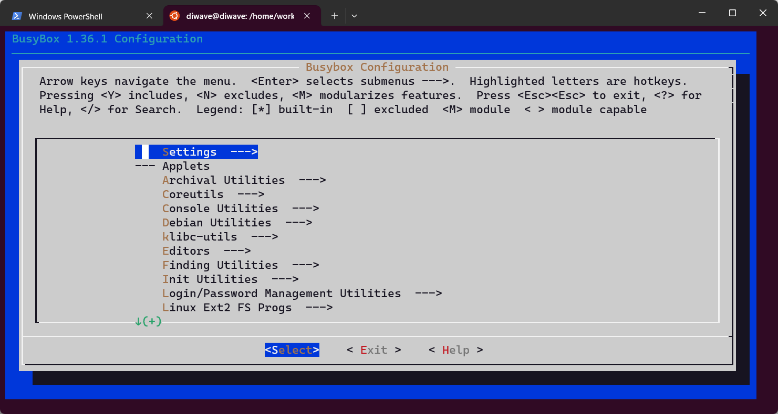

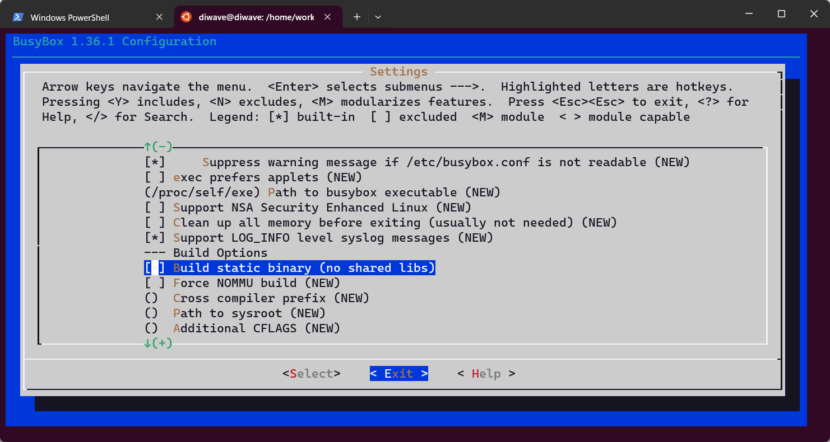

----

以上配置主要是为busybox启动静态链接，方便qemu虚拟机中执行（免去了动态链接库的配置等复杂流程）

编译、安装：

make install -j$(nproc)

-j$(nproc)表示什么意思？？？

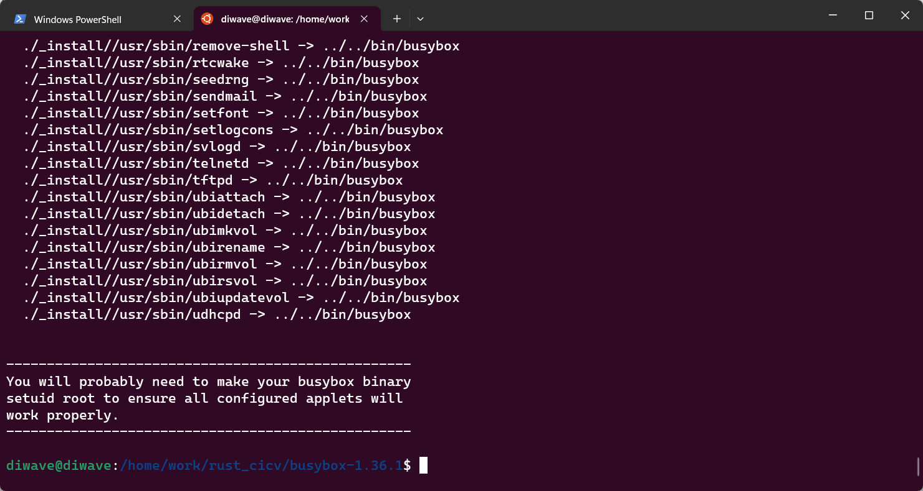

------------------

成功后，在当前目录下会生成_install目录，该目录bin/中存放了编译生成的busybox，同时生成了sbin/，usr/bin/，usr/sbin/等目录，并在相关目录下生成了符号链接指向busybox。这样一套基础的、简单的userland工具就生成好了，以便于我们在qemu虚拟机中使用。

**安装qemu**

apt install qemu-system-x86

qemu-system-x86_64 --version

应该可以看到某个特定的qemu版本号，Debian 12中输出如下

QEMU emulator version 7.2.5 (Debian 1:7.2+dfsg-7+deb12u2)

Copyright (c) 2003-2022 Fabrice Bellard and the QEMU Project developers

-------

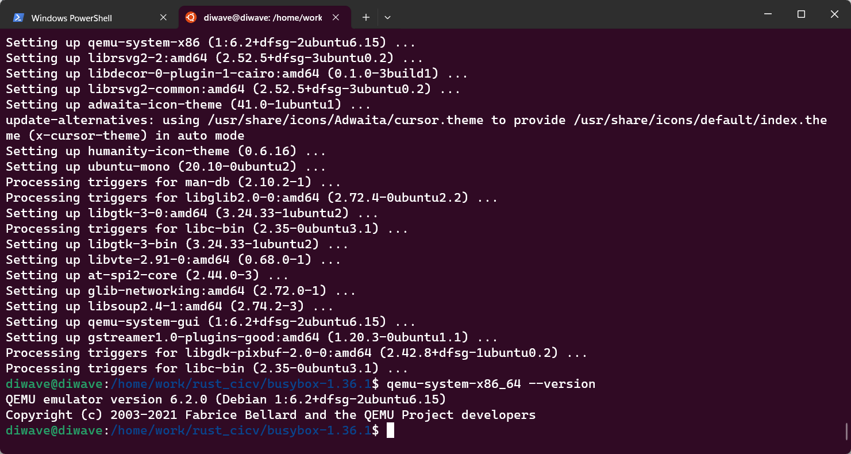

==> qemu的版本6.2.0升级需要升级到7.2.5

[Ubuntu20.04 上安装Qemu 6.1.1_ubuntu升级qemu_akaiziyou的博客-CSDN博客](https://blog.csdn.net/akaiziyou/article/details/122231444)

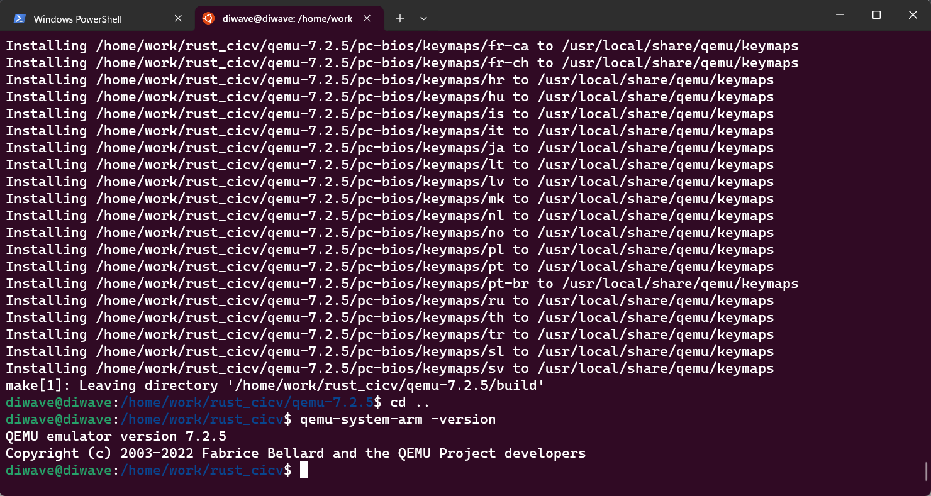

--

**安装rust**

安装rust工具链，一般使用官网推荐的sh脚本自动安装

curl --proto '=https' --tlsv1.2 -sSf <https://sh.rustup.rs> | sh

rust安装程序会自动安装几个主要组件，如cargo, clippy, rust-docs, rust-std, rustc, rustfmt

Rust工具链服务器位于境外，如果安装时网速太慢，可以使用中科大提供的反向代理，使用说明可以参见<https://mirrors.ustc.edu.cn/help/rust-static.html>

另外cargo工具的仓库crates.io也可使用中科大镜像，使用方法参见<https://mirrors.ustc.edu.cn/help/crates.io-index.html>

**配置Linux文件夹**

为了让您的Linux内核代码能够支持Rust，需要进行相关的配置。

可参考内核文档<https://www.kernel.org/doc/html/next/rust/quick-start.html>

在您的仓库中，我们提供了一份Linux内核代码

cd linux

# 将此目录中的rustc重置为特定版本

# 可提前为rustup设置代理，以便加速下载过程，参考上一节“安装Rust”中的说明

rustup override set $(scripts/min-tool-version.sh rustc)

# 添加rust-src源代码 // 还未下载成功====

rustup component add rust-src

# 安装clang llvm，该项一般在配置内核时已经安装，若已安装此处可忽略

apt install clang llvm

# 可为cargo仓库crates.io设置使用镜像，参考上一节“安装Rust”中的说明

# 安装bindgen工具，注意在0.60版本后，bindgen工具的命令行版本位于bindgen-cli包中

cargo install --locked --version $(scripts/min-tool-version.sh bindgen) bindgen

# 安装rustfmt和clippy

rustup component add rustfmt

rustup component add clippy

# 检查内核rust支持已经启用

make LLVM=1 rustavailable

----

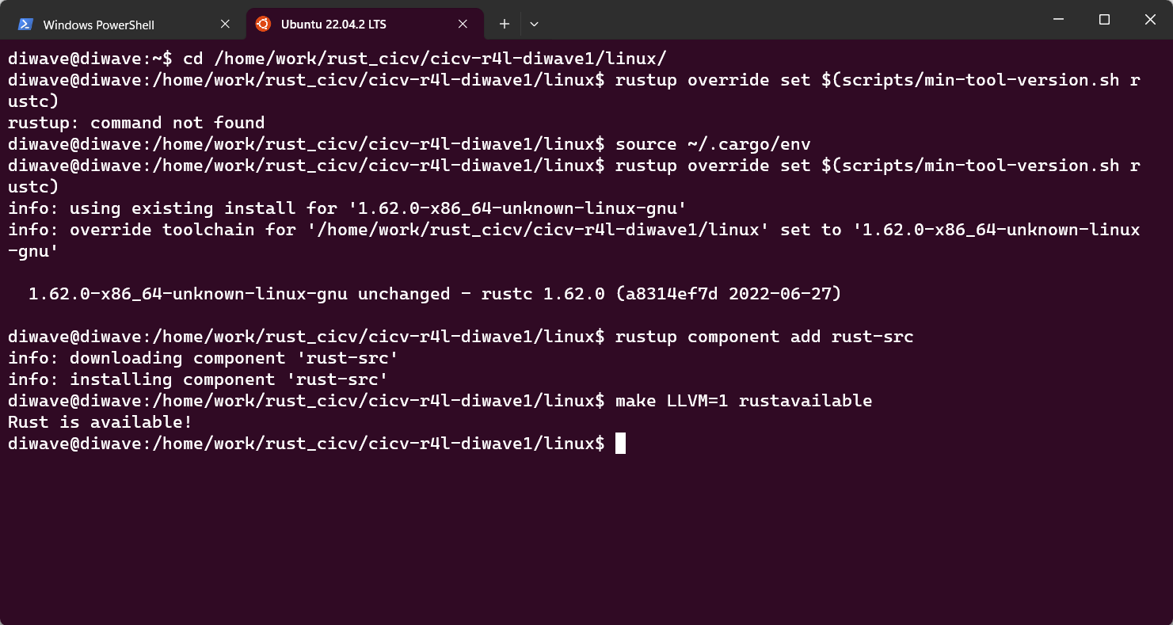

**课程作业内容**

**作业1：编译Linux内核**

**作业说明：**

进入Linux文件夹，使用如下命令进行编译：

make x86_64_defconfig

make LLVM=1 menuconfig

#set the following config to yes

General setup

        ---> [*] Rust support

make LLVM=1 -j$(nproc)

-----

make x86_64_defconfig

==>

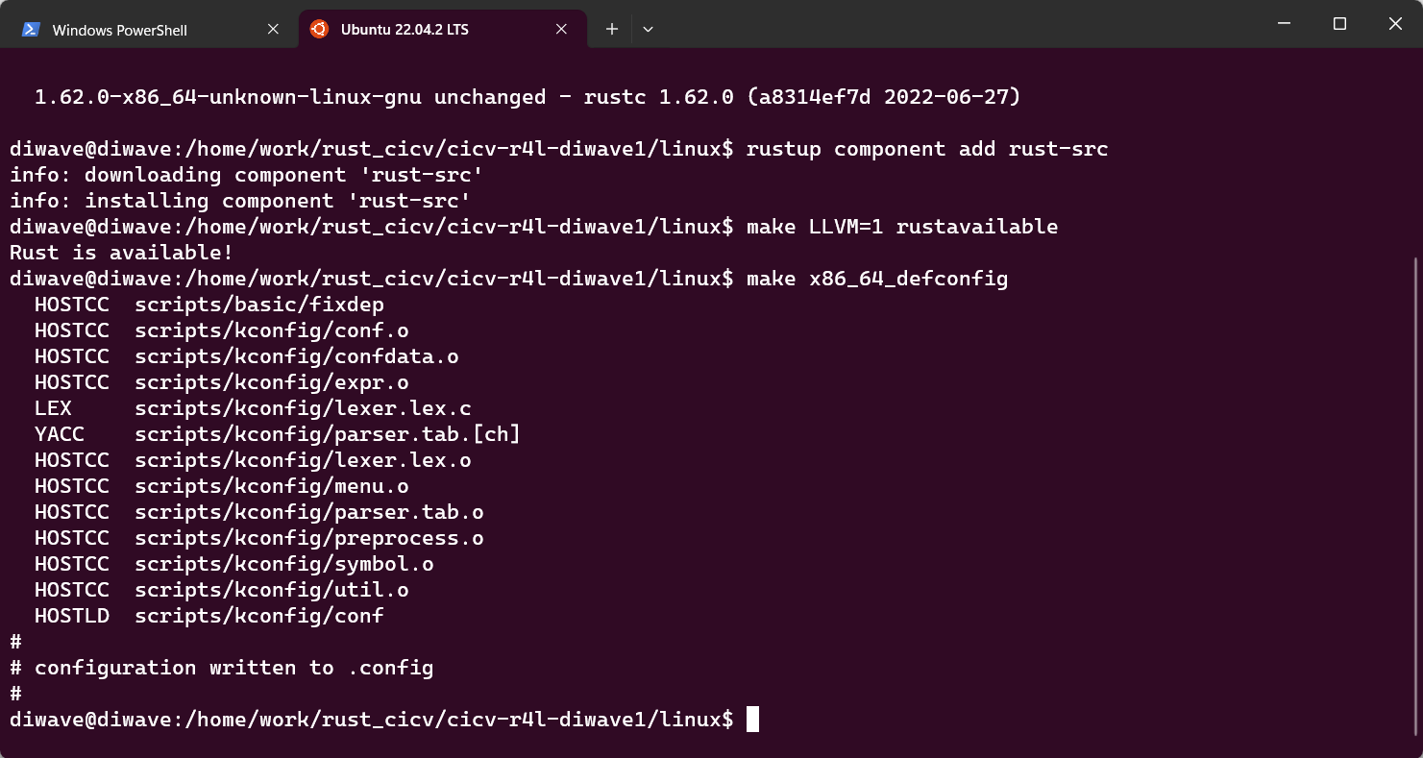

make LLVM=1 menuconfig ==>

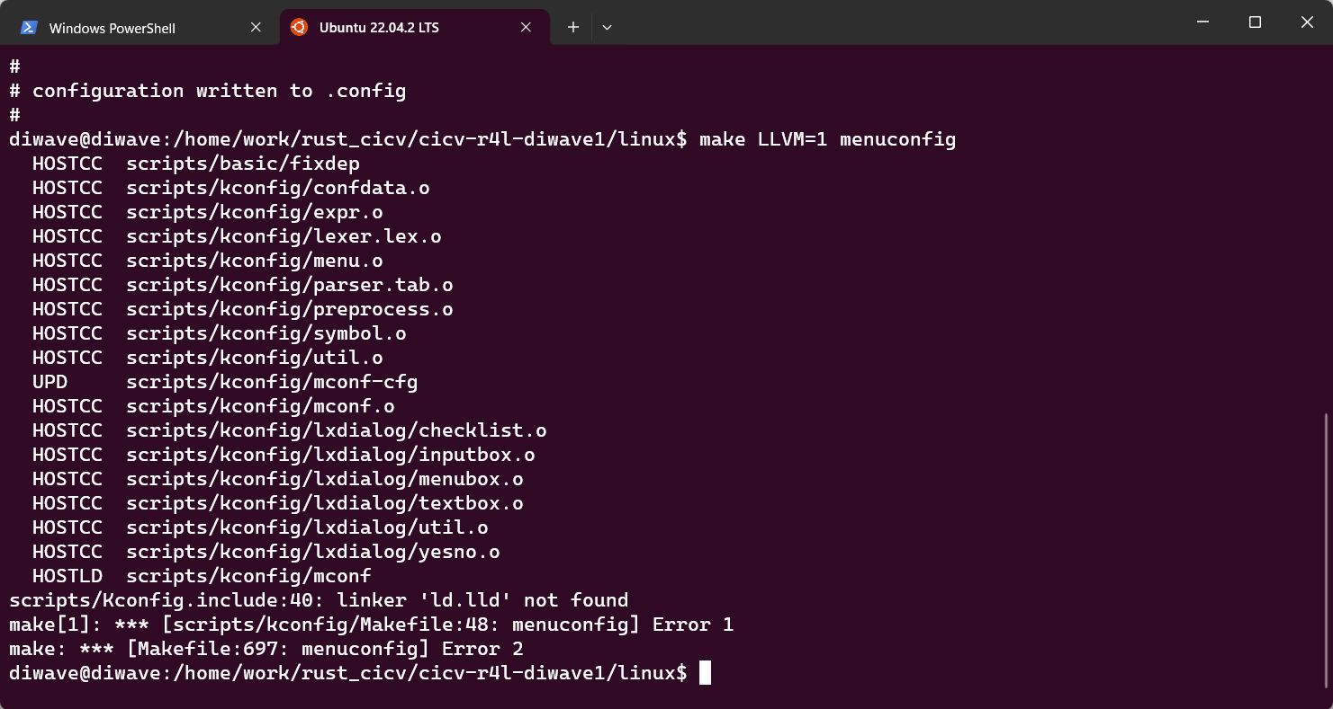

==>编译不通过是由于缺少安装llvm

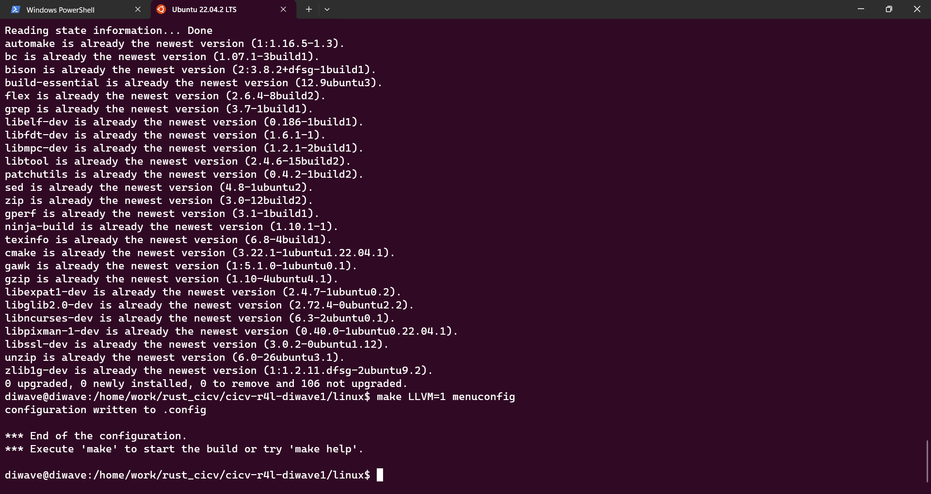

-----

make LLVM=1 -j$(nproc)==>

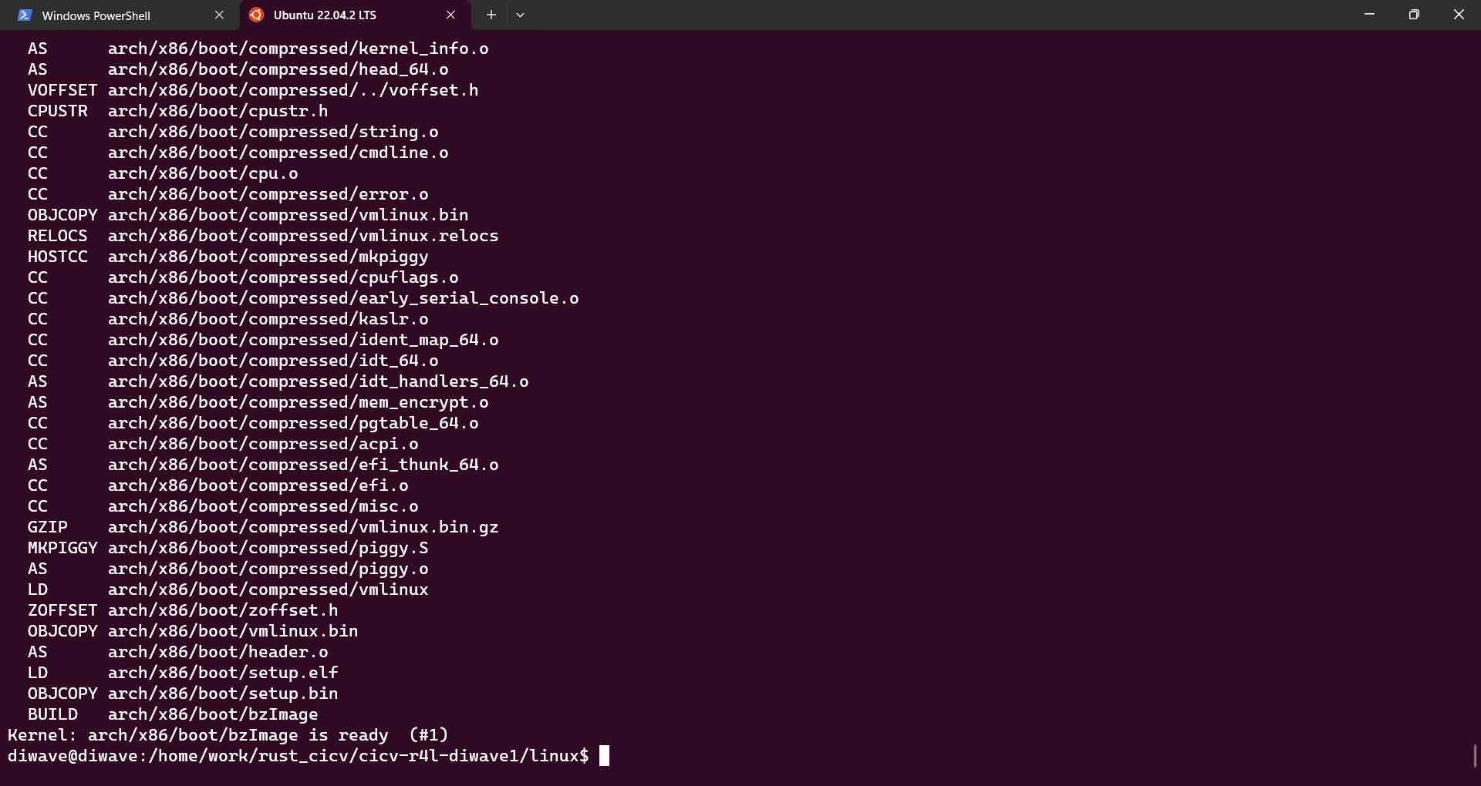

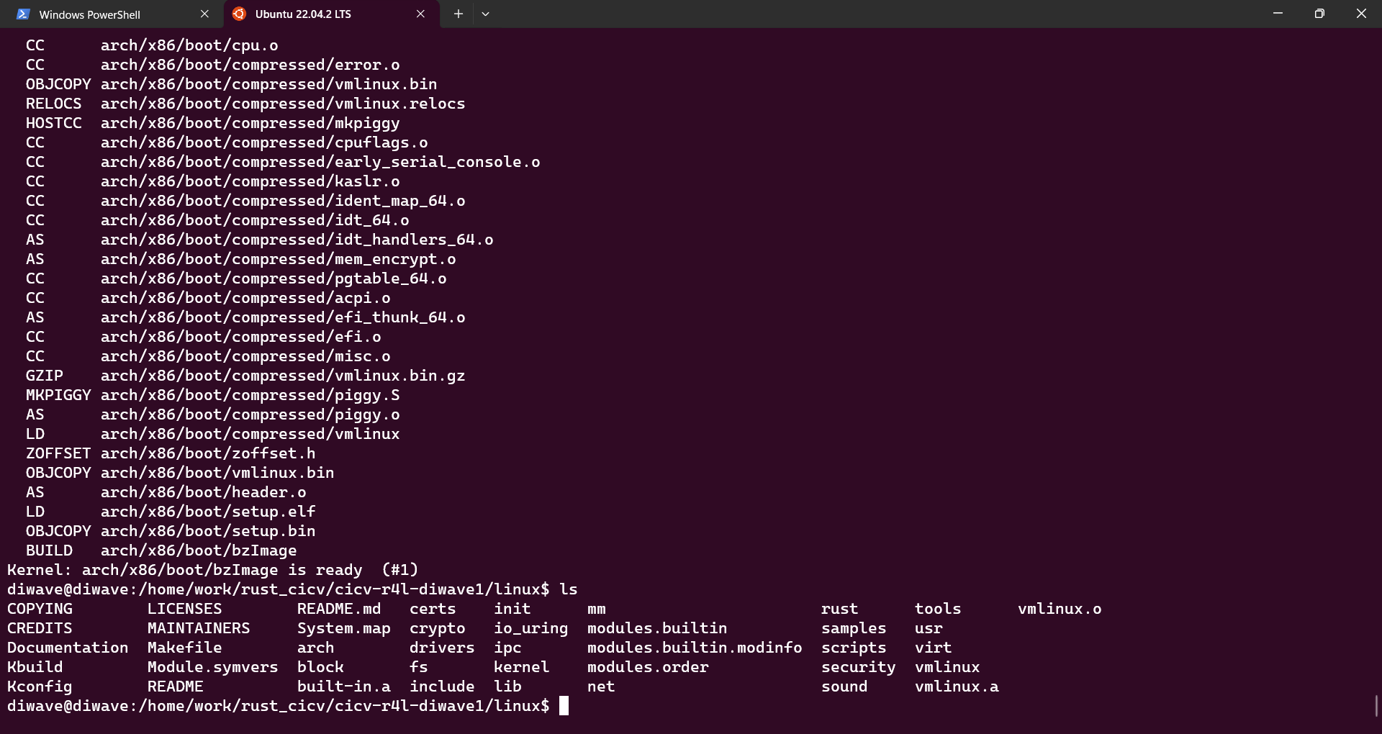

在最后你将在Linux文件夹下，得到一个**vmlinux**的文件，那么就算成功了

**测试样例和分数说明：**

测试样例：无

您只需要在作业报告中，记录这些步骤即可。

分数：本测试占20%的分数

**作业2：对Linux内核进行一些配置**

**作业说明：**

我们提供了一份rust版本的网卡驱动的代码，该代码来自于myrfy老师

放置在代码仓库下的src_e1000文件夹下。

**Q: 在该文件夹中调用make LLVM=1，该文件夹内的代码将编译成一个内核模块。请结合你学到的知识，回答以下两个问题：**

1、编译成内核模块，是在哪个文件中以哪条语句定义的？

==》r4l_e1000_demo.rs文件

module! {

    type: E1000KernelMod,

    name: "r4l_e1000_demo",

    author: "Myrfy001",

    description: "Rust for linux e1000 driver demo",

    license: "GPL",

}

2、该模块位于独立的文件夹内，却能编译成Linux内核模块，这叫做out-of-tree module，请分析它是如何与内核代码产生联系的？

==>

在编译内核之后，需要让他运行起来，因此，如果您已经装好了qemu，在src_e1000文件夹下有一个build_image.sh脚本文件（感谢陈庭润大佬贡献的该文件）

你可能需要如下命令让该脚本能够正确运行起来

chmod 777 ./build_image.sh

如果您前面的步骤一切正常，那么运行这个脚本之后，应该就能够进入一个Linux系统下了。

接下来，我们需要将该脚本生成的Linux内核模块r4l_e1000_demo.ko进行安装

关于您的作业内容：

在该Linux系统下，您可以通过ifconfig看到一个除了本地回环之外的网络设备，并且使用ping命令能够正常联通网络。

在默认情况下的e1000网卡驱动被启用了，因此，不能够装上myrfy老师的e1000网卡驱动模块，您需要修改配置，让Linux内核默认的C版本的e1000网卡驱动能够禁用，这是您的作业内容。（配置路径Device Drivers > Network device support > Ethernet driver support > Intel devices, Intel(R) PRO/1000 Gigabit Ethernet support）

随后退出qemu模拟器，重新编译您的内核，并再次进入qemu模拟器。

由于myrfy老师给出的代码仅仅是一个demo，仍然有非常多需要完善的地方，因此这个网卡驱动无法自动进行网络配置，需要您进行手动配置以让他能够联网。

insmod r4l_e1000_demo.ko

ip link set eth0 up

ip addr add broadcast 10.0.2.255 dev eth0

ip addr add 10.0.2.15/255.255.255.0 dev eth0

ip route add default via 10.0.2.1

ping 10.0.2.2

随后您将在其中看到如下输出：

~ # insmod r4l_e1000_demo.ko

[ 33.408293] r4l_e1000_demo: loading out-of-tree module taints kernel.

[ 33.420195] r4l_e1000_demo: Rust for linux e1000 driver demo (init)

[ 33.421074] r4l_e1000_demo: Rust for linux e1000 driver demo (probe): None

[ 33.725683] ACPI: \_SB_.LNKC: Enabled at IRQ 11

[ 33.752030] r4l_e1000_demo: Rust for linux e1000 driver demo (net device get_stats64)

~ # [ 33.757584] insmod (82) used greatest stack depth: 10968 bytes left

ip link set eth0 up

[ 43.024512] r4l_e1000_demo: Rust for linux e1000 driver demo (net device open)

[ 43.029717] r4l_e1000_demo: Rust for linux e1000 driver demo (net device get_stats64)

[ 43.032836] IPv6: ADDRCONF(NETDEV_CHANGE): eth0: link becomes ready

[ 43.038298] r4l_e1000_demo: Rust for linux e1000 driver demo (net device get_stats64)

~ # [ 43.049274] r4l_e1000_demo: Rust for linux e1000 driver demo (net device start_xmit) tdt=0, tdh=0, rdt=7, rdh=0

[ 43.050209] r4l_e1000_demo: Rust for linux e1000 driver demo (handle_irq)

[ 43.050291] r4l_e1000_demo: pending_irqs: 3

[ 43.051226] r4l_e1000_demo: Rust for linux e1000 driver demo (napi poll)

[ 43.109110] r4l_e1000_demo: Rust for linux e1000 driver demo (net device start_xmit) tdt=1, tdh=1, rdt=7, rdh=0

[ 43.109472] r4l_e1000_demo: Rust for linux e1000 driver demo (handle_irq)

[ 43.109510] r4l_e1000_demo: pending_irqs: 3

[ 43.109768] r4l_e1000_demo: Rust for linux e1000 driver demo (napi poll)

[ 43.564271] r4l_e1000_demo: Rust for linux e1000 driver demo (net device start_xmit) tdt=2, tdh=2, rdt=7, rdh=0

[ 43.564591] r4l_e1000_demo: Rust for linux e1000 driver demo (handle_irq)

[ 43.564606] r4l_e1000_demo: pending_irqs: 3

[ 43.564659] r4l_e1000_demo: Rust for linux e1000 driver demo (napi poll)

[ 44.587807] r4l_e1000_demo: Rust for linux e1000 driver demo (net device start_xmit) tdt=3, tdh=3, rdt=7, rdh=0

[ 44.588005] r4l_e1000_demo: Rust for linux e1000 driver demo (handle_irq)

[ 44.588019] r4l_e1000_demo: pending_irqs: 3

[ 44.588073] r4l_e1000_demo: Rust for linux e1000 driver demo (napi poll)

[ 44.588958] r4l_e1000_demo: Rust for linux e1000 driver demo (net device start_xmit) tdt=4, tdh=4, rdt=7, rdh=0

[ 44.589240] r4l_e1000_demo: Rust for linux e1000 driver demo (handle_irq)

[ 44.589260] r4l_e1000_demo: pending_irqs: 3

[ 44.589305] r4l_e1000_demo: Rust for linux e1000 driver demo (napi poll)

[ 45.290988] r4l_e1000_demo: Rust for linux e1000 driver demo (net device start_xmit) tdt=5, tdh=5, rdt=7, rdh=0

[ 45.291202] r4l_e1000_demo: Rust for linux e1000 driver demo (handle_irq)

[ 45.291217] r4l_e1000_demo: pending_irqs: 3

[ 45.291272] r4l_e1000_demo: Rust for linux e1000 driver demo (napi poll)

[ 48.810408] r4l_e1000_demo: Rust for linux e1000 driver demo (net device start_xmit) tdt=6, tdh=6, rdt=7, rdh=0

[ 48.811582] r4l_e1000_demo: Rust for linux e1000 driver demo (handle_irq)

[ 48.811601] r4l_e1000_demo: pending_irqs: 3

[ 48.812491] r4l_e1000_demo: Rust for linux e1000 driver demo (napi poll)

~ # ip addr add broadcast [ 57.002333] r4l_e1000_demo: Rust for linux e1000 driver demo (net device start_xmit) tdt=70[ 57.002751] r4l_e1000_demo: Rust for linux e1000 driver demo (handle_irq)

[ 57.002768] r4l_e1000_demo: pending_irqs: 3

[ 57.005316] r4l_e1000_demo: Rust for linux e1000 driver demo (napi poll)

10.0.2.255 dev eth0

[ 67.486546] r4l_e1000_demo: Rust for linux e1000 driver demo (net device get_stats64)

[ 67.490048] r4l_e1000_demo: Rust for linux e1000 driver demo (net device get_stats64)

ip: RTNETLINK answers: Invalid argument

~ # ip addr add [ 72.874116] r4l_e1000_demo: Rust for linux e1000 driver demo (net device start_xmit) tdt=0, tdh=0, r0[ 72.874668] r4l_e1000_demo: Rust for linux e1000 driver demo (handle_irq)

[ 72.874694] r4l_e1000_demo: pending_irqs: 3

[ 72.876295] r4l_e1000_demo: Rust for linux e1000 driver demo (napi poll)

10.0.2.15/255.255.255.0 dev eth0

[ 89.139296] r4l_e1000_demo: Rust for linux e1000 driver demo (net device get_stats64)

[ 89.139675] r4l_e1000_demo: Rust for linux e1000 driver demo (net device get_stats64)

~ # ip route add default via 10.0.2.1[ 103.082114] r4l_e1000_demo: Rust for linux e1000 driver demo (net device start_0[ 103.082721] r4l_e1000_demo: Rust for linux e1000 driver demo (handle_irq)

[ 103.082753] r4l_e1000_demo: pending_irqs: 3

[ 103.084422] r4l_e1000_demo: Rust for linux e1000 driver demo (napi poll)

~ # ping 10.0.2.2

PING 10.0.2.2 (10.0.2.2): 56 data bytes

[ 111.284341] r4l_e1000_demo: Rust for linux e1000 driver demo (net device start_xmit) tdt=2, tdh=2, rdt=7, rdh=0

[ 111.284767] r4l_e1000_demo: Rust for linux e1000 driver demo (handle_irq)

[ 111.284787] r4l_e1000_demo: pending_irqs: 131

[ 111.285160] r4l_e1000_demo: Rust for linux e1000 driver demo (napi poll)

[ 111.288026] r4l_e1000_demo: Rust for linux e1000 driver demo (net device start_xmit) tdt=3, tdh=3, rdt=0, rdh=1

[ 111.288158] r4l_e1000_demo: Rust for linux e1000 driver demo (handle_irq)

[ 111.288175] r4l_e1000_demo: pending_irqs: 131

[ 111.291707] r4l_e1000_demo: Rust for linux e1000 driver demo (napi poll)

64 bytes from 10.0.2.2: seq=0 ttl=255 time=20.720 ms

[ 112.300467] r4l_e1000_demo: Rust for linux e1000 driver demo (net device start_xmit) tdt=4, tdh=4, rdt=1, rdh=2

[ 112.301079] r4l_e1000_demo: Rust for linux e1000 driver demo (handle_irq)

[ 112.301119] r4l_e1000_demo: pending_irqs: 131

[ 112.301284] r4l_e1000_demo: Rust for linux e1000 driver demo (napi poll)

64 bytes from 10.0.2.2: seq=1 ttl=255 time=4.724 ms

[ 113.306242] r4l_e1000_demo: Rust for linux e1000 driver demo (net device start_xmit) tdt=5, tdh=5, rdt=2, rdh=3

[ 113.306751] r4l_e1000_demo: Rust for linux e1000 driver demo (handle_irq)

[ 113.306780] r4l_e1000_demo: pending_irqs: 131

64 bytes from 10.0.2.2: seq=2 ttl=255 time=6.790 ms

[ 113.306874] r4l_e1000_demo: Rust for linux e1000 driver demo (napi poll)

^C

--- 10.0.2.2 ping statistics ---

3 packets transmitted, 3 packets received, 0% packet loss

round-trip min/avg/max = 4.724/10.744/20.720 ms

===>

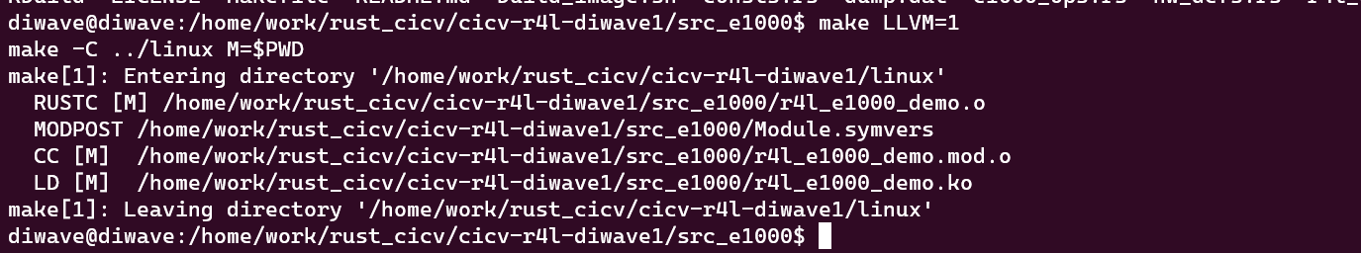

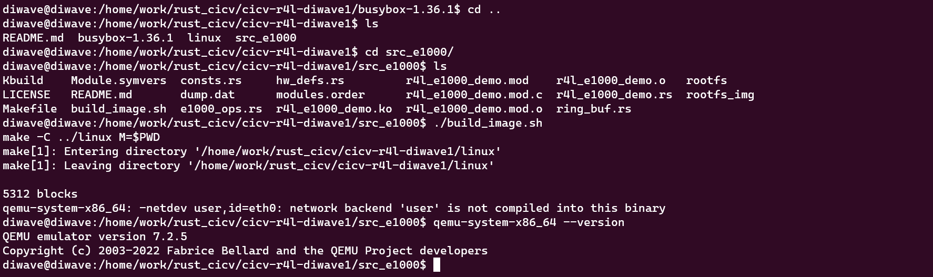

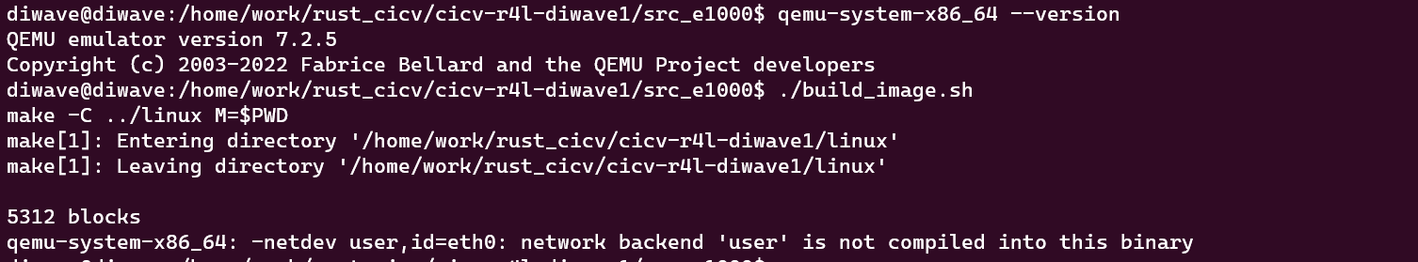

==>解决

[qemu v7.2 network backend ‘user‘ is not compiled into this binary 问题_network backend 'user' is not compiled into this b_qq502233945的博客-CSDN博客](https://blog.csdn.net/qq502233945/article/details/128374465)

[ 0.000000] Linux version 6.1.0-rc1 (diwave@diwave) (Ubuntu clang version 14.0.0-1ubuntu1.1, Ubuntu LLD 14.0.0) #1 SMP PREEMPT_DYNAMIC Thu N3

[ 0.000000] Command line: root=/dev/ram rdinit=sbin/init ip=10.0.2.15::10.0.2.1:255.255.255.0 console=ttyS0 no_timer_check

[ 0.000000] x86/fpu: x87 FPU will use FXSAVE

[ 0.000000] signal: max sigframe size: 1440

[ 0.000000] BIOS-provided physical RAM map:

[ 0.000000] BIOS-e820: [mem 0x0000000000000000-0x000000000009fbff] usable

[ 0.000000] BIOS-e820: [mem 0x000000000009fc00-0x000000000009ffff] reserved

[ 0.000000] BIOS-e820: [mem 0x00000000000f0000-0x00000000000fffff] reserved

[ 0.000000] BIOS-e820: [mem 0x0000000000100000-0x0000000007fdffff] usable

[ 0.000000] BIOS-e820: [mem 0x0000000007fe0000-0x0000000007ffffff] reserved

[ 0.000000] BIOS-e820: [mem 0x00000000fffc0000-0x00000000ffffffff] reserved

[ 0.000000] BIOS-e820: [mem 0x000000fd00000000-0x000000ffffffffff] reserved

[ 0.000000] NX (Execute Disable) protection: active

[ 0.000000] SMBIOS 2.8 present.

[ 0.000000] DMI: QEMU Standard PC (i440FX + PIIX, 1996), BIOS rel-1.16.1-0-g3208b098f51a-prebuilt.qemu.org 04/01/2014

[ 0.000000] tsc: Fast TSC calibration using PIT

[ 0.000000] tsc: Detected 1992.016 MHz processor

[ 0.006625] last_pfn = 0x7fe0 max_arch_pfn = 0x400000000

[ 0.007405] x86/PAT: Configuration [0-7]: WB WC UC- UC WB WP UC- WT

[ 0.018529] found SMP MP-table at [mem 0x000f5c00-0x000f5c0f]

[ 0.023152] RAMDISK: [mem 0x07d48000-0x07fdffff]

[ 0.023913] ACPI: Early table checksum verification disabled

[ 0.024180] ACPI: RSDP 0x00000000000F5A20 000014 (v00 BOCHS )

[ 0.024445] ACPI: RSDT 0x0000000007FE1AC6 000034 (v01 BOCHS BXPC 00000001 BXPC 00000001)

[ 0.024962] ACPI: FACP 0x0000000007FE197A 000074 (v01 BOCHS BXPC 00000001 BXPC 00000001)

[ 0.025669] ACPI: DSDT 0x0000000007FE0040 00193A (v01 BOCHS BXPC 00000001 BXPC 00000001)

[ 0.025743] ACPI: FACS 0x0000000007FE0000 000040

[ 0.025784] ACPI: APIC 0x0000000007FE19EE 000078 (v01 BOCHS BXPC 00000001 BXPC 00000001)

[ 0.025802] ACPI: HPET 0x0000000007FE1A66 000038 (v01 BOCHS BXPC 00000001 BXPC 00000001)

[ 0.025817] ACPI: WAET 0x0000000007FE1A9E 000028 (v01 BOCHS BXPC 00000001 BXPC 00000001)

[ 0.025880] ACPI: Reserving FACP table memory at [mem 0x7fe197a-0x7fe19ed]

[ 0.025905] ACPI: Reserving DSDT table memory at [mem 0x7fe0040-0x7fe1979]

[ 0.025912] ACPI: Reserving FACS table memory at [mem 0x7fe0000-0x7fe003f]

[ 0.025916] ACPI: Reserving APIC table memory at [mem 0x7fe19ee-0x7fe1a65]

[ 0.025920] ACPI: Reserving HPET table memory at [mem 0x7fe1a66-0x7fe1a9d]

[ 0.025924] ACPI: Reserving WAET table memory at [mem 0x7fe1a9e-0x7fe1ac5]

[ 0.027525] No NUMA configuration found

[ 0.027544] Faking a node at [mem 0x0000000000000000-0x0000000007fdffff]

[ 0.028160] NODE_DATA(0) allocated [mem 0x07d44000-0x07d47fff]

[ 0.030074] Zone ranges:

[ 0.030084] DMA [mem 0x0000000000001000-0x0000000000ffffff]

[ 0.030201] DMA32 [mem 0x0000000001000000-0x0000000007fdffff]

[ 0.030209] Normal empty

[ 0.030225] Movable zone start for each node

[ 0.030250] Early memory node ranges

[ 0.030277] node 0: [mem 0x0000000000001000-0x000000000009efff]

[ 0.030467] node 0: [mem 0x0000000000100000-0x0000000007fdffff]

[ 0.030653] Initmem setup node 0 [mem 0x0000000000001000-0x0000000007fdffff]

[ 0.031732] On node 0, zone DMA: 1 pages in unavailable ranges

[ 0.032045] On node 0, zone DMA: 97 pages in unavailable ranges

[ 0.033036] On node 0, zone DMA32: 32 pages in unavailable ranges

[ 0.033363] ACPI: PM-Timer IO Port: 0x608

[ 0.033789] ACPI: LAPIC_NMI (acpi_id[0xff] dfl dfl lint[0x1])

[ 0.034132] IOAPIC[0]: apic_id 0, version 32, address 0xfec00000, GSI 0-23

[ 0.034230] ACPI: INT_SRC_OVR (bus 0 bus_irq 0 global_irq 2 dfl dfl)

[ 0.034442] ACPI: INT_SRC_OVR (bus 0 bus_irq 5 global_irq 5 high level)

[ 0.034479] ACPI: INT_SRC_OVR (bus 0 bus_irq 9 global_irq 9 high level)

[ 0.034557] ACPI: INT_SRC_OVR (bus 0 bus_irq 10 global_irq 10 high level)

[ 0.034565] ACPI: INT_SRC_OVR (bus 0 bus_irq 11 global_irq 11 high level)

[ 0.034758] ACPI: Using ACPI (MADT) for SMP configuration information

[ 0.034795] ACPI: HPET id: 0x8086a201 base: 0xfed00000

[ 0.035062] smpboot: Allowing 1 CPUs, 0 hotplug CPUs

[ 0.035823] PM: hibernation: Registered nosave memory: [mem 0x00000000-0x00000fff]

[ 0.035872] PM: hibernation: Registered nosave memory: [mem 0x0009f000-0x0009ffff]

[ 0.035907] PM: hibernation: Registered nosave memory: [mem 0x000a0000-0x000effff]

[ 0.035912] PM: hibernation: Registered nosave memory: [mem 0x000f0000-0x000fffff]

[ 0.036021] [mem 0x08000000-0xfffbffff] available for PCI devices

[ 0.036042] Booting paravirtualized kernel on bare hardware

[ 0.036277] clocksource: refined-jiffies: mask: 0xffffffff max_cycles: 0xffffffff, max_idle_ns: 1910969940391419 ns

[ 0.045863] setup_percpu: NR_CPUS:64 nr_cpumask_bits:1 nr_cpu_ids:1 nr_node_ids:1

[ 0.047366] percpu: Embedded 52 pages/cpu s175720 r8192 d29080 u2097152

[ 0.049462] Fallback order for Node 0: 0

[ 0.049683] Built 1 zonelists, mobility grouping on. Total pages: 31968

[ 0.049707] Policy zone: DMA32

[ 0.049895] Kernel command line: root=/dev/ram rdinit=sbin/init ip=10.0.2.15::10.0.2.1:255.255.255.0 console=ttyS0 no_timer_check

[ 0.051368] Dentry cache hash table entries: 16384 (order: 5, 131072 bytes, linear)

[ 0.051483] Inode-cache hash table entries: 8192 (order: 4, 65536 bytes, linear)

[ 0.052915] mem auto-init: stack:off, heap alloc:off, heap free:off

[ 0.057811] Memory: 89608K/130552K available (16396K kernel code, 2548K rwdata, 5320K rodata, 1324K init, 1400K bss, 40684K reserved, 0K cma)

[ 0.061126] SLUB: HWalign=64, Order=0-3, MinObjects=0, CPUs=1, Nodes=1

[ 0.069517] Dynamic Preempt: voluntary

[ 0.072461] rcu: Preemptible hierarchical RCU implementation.

[ 0.072475] rcu: RCU event tracing is enabled.

[ 0.072498] rcu: RCU restricting CPUs from NR_CPUS=64 to nr_cpu_ids=1.

[ 0.072605] Trampoline variant of Tasks RCU enabled.

[ 0.072679] rcu: RCU calculated value of scheduler-enlistment delay is 100 jiffies.

[ 0.072702] rcu: Adjusting geometry for rcu_fanout_leaf=16, nr_cpu_ids=1

[ 0.080164] NR_IRQS: 4352, nr_irqs: 256, preallocated irqs: 16

[ 0.084969] rcu: srcu_init: Setting srcu_struct sizes based on contention.

[ 0.090488] Console: colour VGA+ 80x25

[ 0.155835] printk: console [ttyS0] enabled

[ 0.157125] ACPI: Core revision 20220331

[ 0.162203] clocksource: hpet: mask: 0xffffffff max_cycles: 0xffffffff, max_idle_ns: 19112604467 ns

[ 0.167210] APIC: Switch to symmetric I/O mode setup

[ 0.171761] ..TIMER: vector=0x30 apic1=0 pin1=2 apic2=-1 pin2=-1

[ 0.173184] clocksource: tsc-early: mask: 0xffffffffffffffff max_cycles: 0x396d7030be2, max_idle_ns: 881590679739 ns

[ 0.174116] Calibrating delay loop (skipped), value calculated using timer frequency.. 3984.03 BogoMIPS (lpj=1992016)

[ 0.174674] pid_max: default: 32768 minimum: 301

[ 0.176711] LSM: Security Framework initializing

[ 0.178559] SELinux: Initializing.

[ 0.180546] Mount-cache hash table entries: 512 (order: 0, 4096 bytes, linear)

[ 0.180870] Mountpoint-cache hash table entries: 512 (order: 0, 4096 bytes, linear)

[ 0.201695] process: using AMD E400 aware idle routine

[ 0.202064] Last level iTLB entries: 4KB 512, 2MB 255, 4MB 127

[ 0.202318] Last level dTLB entries: 4KB 512, 2MB 255, 4MB 127, 1GB 0

[ 0.203225] Spectre V1 : Mitigation: usercopy/swapgs barriers and __user pointer sanitization

[ 0.204084] Spectre V2 : Mitigation: Retpolines

[ 0.204661] Spectre V2 : Spectre v2 / SpectreRSB mitigation: Filling RSB on context switch

[ 0.205568] Spectre V2 : Spectre v2 / SpectreRSB : Filling RSB on VMEXIT

[ 0.495021] Freeing SMP alternatives memory: 52K

[ 0.609333] smpboot: CPU0: AMD QEMU Virtual CPU version 2.5+ (family: 0xf, model: 0x6b, stepping: 0x1)

[ 0.615306] cblist_init_generic: Setting adjustable number of callback queues.

[ 0.615902] cblist_init_generic: Setting shift to 0 and lim to 1.

[ 0.616479] Performance Events: PMU not available due to virtualization, using software events only.

[ 0.618999] rcu: Hierarchical SRCU implementation.

[ 0.619425] rcu: Max phase no-delay instances is 400.

[ 0.625167] smp: Bringing up secondary CPUs ...

[ 0.625720] smp: Brought up 1 node, 1 CPU

[ 0.625927] smpboot: Max logical packages: 1

[ 0.626305] smpboot: Total of 1 processors activated (3984.03 BogoMIPS)

[ 0.639506] devtmpfs: initialized

[ 0.648617] clocksource: jiffies: mask: 0xffffffff max_cycles: 0xffffffff, max_idle_ns: 1911260446275000 ns

[ 0.649975] futex hash table entries: 256 (order: 2, 16384 bytes, linear)

[ 0.653020] PM: RTC time: 23:58:34, date: 2023-11-08

[ 0.657803] NET: Registered PF_NETLINK/PF_ROUTE protocol family

[ 0.660898] audit: initializing netlink subsys (disabled)

[ 0.665339] audit: type=2000 audit(1699487913.497:1): state=initialized audit_enabled=0 res=1

[ 0.667331] thermal_sys: Registered thermal governor 'step_wise'

[ 0.667372] thermal_sys: Registered thermal governor 'user_space'

[ 0.669896] cpuidle: using governor menu

[ 0.673580] PCI: Using configuration type 1 for base access

[ 0.701319] kprobes: kprobe jump-optimization is enabled. All kprobes are optimized if possible.

[ 1.096247] HugeTLB: registered 2.00 MiB page size, pre-allocated 0 pages

[ 1.096608] HugeTLB: 28 KiB vmemmap can be freed for a 2.00 MiB page

[ 1.103212] ACPI: Added _OSI(Module Device)

[ 1.103410] ACPI: Added _OSI(Processor Device)

[ 1.103930] ACPI: Added _OSI(3.0 _SCP Extensions)

[ 1.104348] ACPI: Added _OSI(Processor Aggregator Device)

[ 1.117344] ACPI: 1 ACPI AML tables successfully acquired and loaded

[ 1.132230] ACPI: Interpreter enabled

[ 1.133923] ACPI: PM: (supports S0 S3 S4 S5)

[ 1.134314] ACPI: Using IOAPIC for interrupt routing

[ 1.135080] PCI: Using host bridge windows from ACPI; if necessary, use "pci=nocrs" and report a bug

[ 1.135692] PCI: Using E820 reservations for host bridge windows

[ 1.137595] ACPI: Enabled 2 GPEs in block 00 to 0F

[ 1.168822] ACPI: PCI Root Bridge [PCI0] (domain 0000 [bus 00-ff])

[ 1.170032] acpi PNP0A03:00: _OSC: OS supports [ASPM ClockPM Segments MSI HPX-Type3]

[ 1.170922] acpi PNP0A03:00: _OSC: not requesting OS control; OS requires [ExtendedConfig ASPM ClockPM MSI]

[ 1.172511] acpi PNP0A03:00: fail to add MMCONFIG information, can't access extended PCI configuration space under this bridge.

[ 1.176570] PCI host bridge to bus 0000:00

[ 1.177055] pci_bus 0000:00: root bus resource [io 0x0000-0x0cf7 window]

[ 1.177899] pci_bus 0000:00: root bus resource [io 0x0d00-0xffff window]

[ 1.178912] pci_bus 0000:00: root bus resource [mem 0x000a0000-0x000bffff window]

[ 1.179338] pci_bus 0000:00: root bus resource [mem 0x08000000-0xfebfffff window]

[ 1.179906] pci_bus 0000:00: root bus resource [mem 0x100000000-0x17fffffff window]

[ 1.181159] pci_bus 0000:00: root bus resource [bus 00-ff]

[ 1.182997] pci 0000:00:00.0: [8086:1237] type 00 class 0x060000

[ 1.191298] pci 0000:00:01.0: [8086:7000] type 00 class 0x060100

[ 1.195584] pci 0000:00:01.1: [8086:7010] type 00 class 0x010180

[ 1.198110] pci 0000:00:01.1: reg 0x20: [io 0xc040-0xc04f]

[ 1.198899] pci 0000:00:01.1: legacy IDE quirk: reg 0x10: [io 0x01f0-0x01f7]

[ 1.199891] pci 0000:00:01.1: legacy IDE quirk: reg 0x14: [io 0x03f6]

[ 1.200919] pci 0000:00:01.1: legacy IDE quirk: reg 0x18: [io 0x0170-0x0177]

[ 1.201456] pci 0000:00:01.1: legacy IDE quirk: reg 0x1c: [io 0x0376]

[ 1.202383] pci 0000:00:01.3: [8086:7113] type 00 class 0x068000

[ 1.203113] pci 0000:00:01.3: quirk: [io 0x0600-0x063f] claimed by PIIX4 ACPI

[ 1.203810] pci 0000:00:01.3: quirk: [io 0x0700-0x070f] claimed by PIIX4 SMB

[ 1.204742] pci 0000:00:02.0: [1234:1111] type 00 class 0x030000

[ 1.205465] pci 0000:00:02.0: reg 0x10: [mem 0xfd000000-0xfdffffff pref]

[ 1.207870] pci 0000:00:02.0: reg 0x18: [mem 0xfebf0000-0xfebf0fff]

[ 1.210146] pci 0000:00:02.0: reg 0x30: [mem 0xfebe0000-0xfebeffff pref]

[ 1.211120] pci 0000:00:02.0: Video device with shadowed ROM at [mem 0x000c0000-0x000dffff]

[ 1.216418] pci 0000:00:03.0: [8086:100e] type 00 class 0x020000

[ 1.216870] pci 0000:00:03.0: reg 0x10: [mem 0xfebc0000-0xfebdffff]

[ 1.218351] pci 0000:00:03.0: reg 0x14: [io 0xc000-0xc03f]

[ 1.219870] pci 0000:00:03.0: reg 0x30: [mem 0xfeb80000-0xfebbffff pref]

[ 1.228985] ACPI: PCI: Interrupt link LNKA configured for IRQ 10

[ 1.230440] ACPI: PCI: Interrupt link LNKB configured for IRQ 10

[ 1.231912] ACPI: PCI: Interrupt link LNKC configured for IRQ 11

[ 1.232897] ACPI: PCI: Interrupt link LNKD configured for IRQ 11

[ 1.233606] ACPI: PCI: Interrupt link LNKS configured for IRQ 9

[ 1.237319] iommu: Default domain type: Translated

[ 1.237585] iommu: DMA domain TLB invalidation policy: lazy mode

[ 1.239678] SCSI subsystem initialized

[ 1.241533] ACPI: bus type USB registered

[ 1.242357] usbcore: registered new interface driver usbfs

[ 1.243233] usbcore: registered new interface driver hub

[ 1.244069] usbcore: registered new device driver usb

[ 1.244827] pps_core: LinuxPPS API ver. 1 registered

[ 1.244913] pps_core: Software ver. 5.3.6 - Copyright 2005-2007 Rodolfo Giometti <giometti@linux.it>

[ 1.245918] PTP clock support registered

[ 1.248550] Advanced Linux Sound Architecture Driver Initialized.

[ 1.257922] NetLabel: Initializing

[ 1.258063] NetLabel: domain hash size = 128

[ 1.258340] NetLabel: protocols = UNLABELED CIPSOv4 CALIPSO

[ 1.259773] NetLabel: unlabeled traffic allowed by default

[ 1.264320] PCI: Using ACPI for IRQ routing

[ 1.267451] pci 0000:00:02.0: vgaarb: setting as boot VGA device

[ 1.267870] pci 0000:00:02.0: vgaarb: bridge control possible

[ 1.267870] pci 0000:00:02.0: vgaarb: VGA device added: decodes=io+mem,owns=io+mem,locks=none

[ 1.267914] vgaarb: loaded

[ 1.269360] hpet: 3 channels of 0 reserved for per-cpu timers

[ 1.269918] hpet0: at MMIO 0xfed00000, IRQs 2, 8, 0

[ 1.270151] hpet0: 3 comparators, 64-bit 100.000000 MHz counter

[ 1.274630] clocksource: Switched to clocksource tsc-early

[ 1.281242] VFS: Disk quotas dquot_6.6.0

[ 1.281802] VFS: Dquot-cache hash table entries: 512 (order 0, 4096 bytes)

[ 1.285258] pnp: PnP ACPI init

[ 1.290193] pnp: PnP ACPI: found 6 devices

[ 1.319196] clocksource: acpi_pm: mask: 0xffffff max_cycles: 0xffffff, max_idle_ns: 2085701024 ns

[ 1.321187] NET: Registered PF_INET protocol family

[ 1.323571] IP idents hash table entries: 2048 (order: 2, 16384 bytes, linear)

[ 1.331134] tcp_listen_portaddr_hash hash table entries: 256 (order: 0, 4096 bytes, linear)

[ 1.332147] Table-perturb hash table entries: 65536 (order: 6, 262144 bytes, linear)

[ 1.333414] TCP established hash table entries: 1024 (order: 1, 8192 bytes, linear)

[ 1.334219] TCP bind hash table entries: 1024 (order: 3, 32768 bytes, linear)

[ 1.335358] TCP: Hash tables configured (established 1024 bind 1024)

[ 1.336756] UDP hash table entries: 256 (order: 1, 8192 bytes, linear)

[ 1.337661] UDP-Lite hash table entries: 256 (order: 1, 8192 bytes, linear)

[ 1.339502] NET: Registered PF_UNIX/PF_LOCAL protocol family

[ 1.341874] RPC: Registered named UNIX socket transport module.

[ 1.342591] RPC: Registered udp transport module.

[ 1.344395] RPC: Registered tcp transport module.

[ 1.346536] RPC: Registered tcp NFSv4.1 backchannel transport module.

[ 1.350016] pci_bus 0000:00: resource 4 [io 0x0000-0x0cf7 window]

[ 1.350447] pci_bus 0000:00: resource 5 [io 0x0d00-0xffff window]

[ 1.350796] pci_bus 0000:00: resource 6 [mem 0x000a0000-0x000bffff window]

[ 1.351415] pci_bus 0000:00: resource 7 [mem 0x08000000-0xfebfffff window]

[ 1.351765] pci_bus 0000:00: resource 8 [mem 0x100000000-0x17fffffff window]

[ 1.353574] pci 0000:00:01.0: PIIX3: Enabling Passive Release

[ 1.354024] pci 0000:00:00.0: Limiting direct PCI/PCI transfers

[ 1.354419] PCI: CLS 0 bytes, default 64

[ 1.363441] Unpacking initramfs...

[ 1.418325] Freeing initrd memory: 2656K

[ 1.521590] Initialise system trusted keyrings

[ 1.524622] workingset: timestamp_bits=56 max_order=15 bucket_order=0

[ 1.539781] NFS: Registering the id_resolver key type

[ 1.540631] Key type id_resolver registered

[ 1.540828] Key type id_legacy registered

[ 1.542306] 9p: Installing v9fs 9p2000 file system support

[ 1.572207] Key type asymmetric registered

[ 1.572514] Asymmetric key parser 'x509' registered

[ 1.573401] Block layer SCSI generic (bsg) driver version 0.4 loaded (major 251)

[ 1.574609] io scheduler mq-deadline registered

[ 1.575164] io scheduler kyber registered

[ 1.579457] input: Power Button as /devices/LNXSYSTM:00/LNXPWRBN:00/input/input0

[ 1.618469] ACPI: button: Power Button [PWRF]

[ 1.622827] Serial: 8250/16550 driver, 4 ports, IRQ sharing enabled

[ 1.625364] 00:04: ttyS0 at I/O 0x3f8 (irq = 4, base_baud = 115200) is a 16550A

[ 1.631885] Non-volatile memory driver v1.3

[ 1.632293] Linux agpgart interface v0.103

[ 1.634564] ACPI: bus type drm_connector registered

[ 1.684609] loop: module loaded

[ 1.693141] scsi host0: ata_piix

[ 1.695651] scsi host1: ata_piix

[ 1.696730] ata1: PATA max MWDMA2 cmd 0x1f0 ctl 0x3f6 bmdma 0xc040 irq 14

[ 1.697376] ata2: PATA max MWDMA2 cmd 0x170 ctl 0x376 bmdma 0xc048 irq 15

[ 1.707181] e100: Intel(R) PRO/100 Network Driver

[ 1.707443] e100: Copyright(c) 1999-2006 Intel Corporation

[ 1.708387] e1000: Intel(R) PRO/1000 Network Driver

[ 1.708645] e1000: Copyright (c) 1999-2006 Intel Corporation.

[ 1.861466] ata2: found unknown device (class 0)

[ 1.867537] ata2.00: ATAPI: QEMU DVD-ROM, 2.5+, max UDMA/100

[ 1.885029] scsi 1:0:0:0: CD-ROM QEMU QEMU DVD-ROM 2.5+ PQ: 0 ANSI: 5

[ 1.922842] sr 1:0:0:0: [sr0] scsi3-mmc drive: 4x/4x cd/rw xa/form2 tray

[ 1.924203] cdrom: Uniform CD-ROM driver Revision: 3.20

[ 1.928580] ACPI: \_SB_.LNKC: Enabled at IRQ 11

[ 1.946165] sr 1:0:0:0: Attached scsi generic sg0 type 5

[ 2.238188] e1000 0000:00:03.0 eth0: (PCI:33MHz:32-bit) 52:54:00:12:34:56

[ 2.239113] e1000 0000:00:03.0 eth0: Intel(R) PRO/1000 Network Connection

[ 2.240350] e1000e: Intel(R) PRO/1000 Network Driver

[ 2.240713] e1000e: Copyright(c) 1999 - 2015 Intel Corporation.

[ 2.241366] sky2: driver version 1.30

[ 2.243705] usbcore: registered new interface driver usblp

[ 2.244326] usbcore: registered new interface driver usb-storage

[ 2.246693] i8042: PNP: PS/2 Controller [PNP0303:KBD,PNP0f13:MOU] at 0x60,0x64 irq 1,12

[ 2.250566] serio: i8042 KBD port at 0x60,0x64 irq 1

[ 2.251233] serio: i8042 AUX port at 0x60,0x64 irq 12

[ 2.255342] input: AT Translated Set 2 keyboard as /devices/platform/i8042/serio0/input/input1

[ 2.264556] rtc_cmos 00:05: registered as rtc0

[ 2.265700] rtc_cmos 00:05: alarms up to one day, 242 bytes nvram, hpet irqs

[ 2.267254] rtc_cmos 00:05: RTC can wake from S4

[ 2.268391] fail to initialize ptp_kvm

[ 2.269288] device-mapper: ioctl: 4.47.0-ioctl (2022-07-28) initialised: dm-devel@redhat.com

[ 2.270637] hid: raw HID events driver (C) Jiri Kosina

[ 2.272566] usbcore: registered new interface driver usbhid

[ 2.272905] usbhid: USB HID core driver

[ 2.282102] Initializing XFRM netlink socket

[ 2.283384] NET: Registered PF_INET6 protocol family

[ 2.298331] Segment Routing with IPv6

[ 2.299063] In-situ OAM (IOAM) with IPv6

[ 2.300546] sit: IPv6, IPv4 and MPLS over IPv4 tunneling driver

[ 2.303534] NET: Registered PF_PACKET protocol family

[ 2.305200] 9pnet: Installing 9P2000 support

[ 2.305706] Key type dns_resolver registered

[ 2.307908] IPI shorthand broadcast: enabled

[ 2.309639] sched_clock: Marking stable (2229428775, 79469842)->(2321754516, -12855899)

[ 2.313364] registered taskstats version 1

[ 2.313639] Loading compiled-in X.509 certificates

[ 2.321347] cryptomgr_test (44) used greatest stack depth: 15584 bytes left

[ 2.331354] PM: Magic number: 15:515:1009

[ 2.332554] printk: console [netcon0] enabled

[ 2.332828] netconsole: network logging started

[ 2.893661] input: ImExPS/2 Generic Explorer Mouse as /devices/platform/i8042/serio1/input/input3

[ 2.939850] e1000: eth0 NIC Link is Up 1000 Mbps Full Duplex, Flow Control: RX

[ 2.955089] IP-Config: Complete:

[ 2.955271] device=eth0, hwaddr=52:54:00:12:34:56, ipaddr=10.0.2.15, mask=255.255.255.0, gw=10.0.2.1

[ 2.955829] host=10.0.2.15, domain=, nis-domain=(none)

[ 2.956227] bootserver=255.255.255.255, rootserver=255.255.255.255, rootpath=

[ 2.960816] cfg80211: Loading compiled-in X.509 certificates for regulatory database

[ 3.023767] modprobe (66) used greatest stack depth: 14272 bytes left

[ 3.037750] cfg80211: Loaded X.509 cert 'sforshee: 00b28ddf47aef9cea7'

[ 3.040154] platform regulatory.0: Direct firmware load for regulatory.db failed with error -2

[ 3.041004] cfg80211: failed to load regulatory.db

[ 3.042771] ALSA device list:

[ 3.043052] No soundcards found.

[ 3.110575] Freeing unused kernel image (initmem) memory: 1324K

[ 3.113287] Write protecting the kernel read-only data: 24576k

[ 3.116561] Freeing unused kernel image (text/rodata gap) memory: 2032K

[ 3.117658] Freeing unused kernel image (rodata/data gap) memory: 824K

[ 3.271505] x86/mm: Checked W+X mappings: passed, no W+X pages found.

[ 3.272366] IPv6: ADDRCONF(NETDEV_CHANGE): eth0: link becomes ready

[ 3.274355] Run sbin/init as init process

[ 3.323581] mount (71) used greatest stack depth: 13920 bytes left

[ 3.397179] tsc: Refined TSC clocksource calibration: 1992.000 MHz

[ 3.397617] clocksource: tsc: mask: 0xffffffffffffffff max_cycles: 0x396d519840e, max_idle_ns: 881590569543 ns

[ 3.398693] clocksource: Switched to clocksource tsc

Please press Enter to activate this console.

~ #

==> 正确

[ 0.000000] Linux version 6.1.0-rc1 (diwave@diwave) (Ubuntu clang version 14.0.0-1ubuntu1.1, Ubuntu LLD 14.0.0) #1 SMP PREEMPT_DYNAMIC Thu Nov 9 22:39:12 CST 2023

[ 0.000000] Command line: root=/dev/ram rdinit=sbin/init ip=10.0.2.15::10.0.2.1:255.255.255.0 console=ttyS0 no_timer_check

[ 0.000000] x86/fpu: x87 FPU will use FXSAVE

[ 0.000000] signal: max sigframe size: 1440

[ 0.000000] BIOS-provided physical RAM map:

[ 0.000000] BIOS-e820: [mem 0x0000000000000000-0x000000000009fbff] usable

[ 0.000000] BIOS-e820: [mem 0x000000000009fc00-0x000000000009ffff] reserved

[ 0.000000] BIOS-e820: [mem 0x00000000000f0000-0x00000000000fffff] reserved

[ 0.000000] BIOS-e820: [mem 0x0000000000100000-0x0000000007fdffff] usable

[ 0.000000] BIOS-e820: [mem 0x0000000007fe0000-0x0000000007ffffff] reserved

[ 0.000000] BIOS-e820: [mem 0x00000000fffc0000-0x00000000ffffffff] reserved

[ 0.000000] BIOS-e820: [mem 0x000000fd00000000-0x000000ffffffffff] reserved

[ 0.000000] NX (Execute Disable) protection: active

[ 0.000000] SMBIOS 2.8 present.

[ 0.000000] DMI: QEMU Standard PC (i440FX + PIIX, 1996), BIOS rel-1.16.1-0-g3208b098f51a-prebuilt.qemu.org 04/01/2014

[ 0.000000] tsc: Fast TSC calibration using PIT

[ 0.000000] tsc: Detected 1992.007 MHz processor

[ 0.006695] last_pfn = 0x7fe0 max_arch_pfn = 0x400000000

[ 0.007485] x86/PAT: Configuration [0-7]: WB WC UC- UC WB WP UC- WT

[ 0.018283] found SMP MP-table at [mem 0x000f5c00-0x000f5c0f]

[ 0.022999] RAMDISK: [mem 0x07d48000-0x07fdffff]

[ 0.023779] ACPI: Early table checksum verification disabled

[ 0.024065] ACPI: RSDP 0x00000000000F5A20 000014 (v00 BOCHS )

[ 0.024355] ACPI: RSDT 0x0000000007FE1AC6 000034 (v01 BOCHS BXPC 00000001 BXPC 00000001)

[ 0.025023] ACPI: FACP 0x0000000007FE197A 000074 (v01 BOCHS BXPC 00000001 BXPC 00000001)

[ 0.025533] ACPI: DSDT 0x0000000007FE0040 00193A (v01 BOCHS BXPC 00000001 BXPC 00000001)

[ 0.025603] ACPI: FACS 0x0000000007FE0000 000040

[ 0.025642] ACPI: APIC 0x0000000007FE19EE 000078 (v01 BOCHS BXPC 00000001 BXPC 00000001)

[ 0.025660] ACPI: HPET 0x0000000007FE1A66 000038 (v01 BOCHS BXPC 00000001 BXPC 00000001)

[ 0.025675] ACPI: WAET 0x0000000007FE1A9E 000028 (v01 BOCHS BXPC 00000001 BXPC 00000001)

[ 0.025754] ACPI: Reserving FACP table memory at [mem 0x7fe197a-0x7fe19ed]

[ 0.025782] ACPI: Reserving DSDT table memory at [mem 0x7fe0040-0x7fe1979]

[ 0.025789] ACPI: Reserving FACS table memory at [mem 0x7fe0000-0x7fe003f]

[ 0.025793] ACPI: Reserving APIC table memory at [mem 0x7fe19ee-0x7fe1a65]

[ 0.025798] ACPI: Reserving HPET table memory at [mem 0x7fe1a66-0x7fe1a9d]

[ 0.025802] ACPI: Reserving WAET table memory at [mem 0x7fe1a9e-0x7fe1ac5]

[ 0.027492] No NUMA configuration found

[ 0.027511] Faking a node at [mem 0x0000000000000000-0x0000000007fdffff]

[ 0.028166] NODE_DATA(0) allocated [mem 0x07d44000-0x07d47fff]

[ 0.030142] Zone ranges:

[ 0.030154] DMA [mem 0x0000000000001000-0x0000000000ffffff]

[ 0.030273] DMA32 [mem 0x0000000001000000-0x0000000007fdffff]

[ 0.030281] Normal empty

[ 0.030298] Movable zone start for each node

[ 0.030323] Early memory node ranges

[ 0.030350] node 0: [mem 0x0000000000001000-0x000000000009efff]

[ 0.030542] node 0: [mem 0x0000000000100000-0x0000000007fdffff]

[ 0.030728] Initmem setup node 0 [mem 0x0000000000001000-0x0000000007fdffff]

[ 0.031816] On node 0, zone DMA: 1 pages in unavailable ranges

[ 0.032112] On node 0, zone DMA: 97 pages in unavailable ranges

[ 0.033105] On node 0, zone DMA32: 32 pages in unavailable ranges

[ 0.033436] ACPI: PM-Timer IO Port: 0x608

[ 0.033865] ACPI: LAPIC_NMI (acpi_id[0xff] dfl dfl lint[0x1])

[ 0.034208] IOAPIC[0]: apic_id 0, version 32, address 0xfec00000, GSI 0-23

[ 0.034306] ACPI: INT_SRC_OVR (bus 0 bus_irq 0 global_irq 2 dfl dfl)

[ 0.034518] ACPI: INT_SRC_OVR (bus 0 bus_irq 5 global_irq 5 high level)

[ 0.034555] ACPI: INT_SRC_OVR (bus 0 bus_irq 9 global_irq 9 high level)

[ 0.034634] ACPI: INT_SRC_OVR (bus 0 bus_irq 10 global_irq 10 high level)

[ 0.034642] ACPI: INT_SRC_OVR (bus 0 bus_irq 11 global_irq 11 high level)

[ 0.034859] ACPI: Using ACPI (MADT) for SMP configuration information

[ 0.034897] ACPI: HPET id: 0x8086a201 base: 0xfed00000

[ 0.035166] smpboot: Allowing 1 CPUs, 0 hotplug CPUs

[ 0.036059] PM: hibernation: Registered nosave memory: [mem 0x00000000-0x00000fff]

[ 0.036123] PM: hibernation: Registered nosave memory: [mem 0x0009f000-0x0009ffff]

[ 0.036174] PM: hibernation: Registered nosave memory: [mem 0x000a0000-0x000effff]

[ 0.036180] PM: hibernation: Registered nosave memory: [mem 0x000f0000-0x000fffff]

[ 0.036310] [mem 0x08000000-0xfffbffff] available for PCI devices

[ 0.036334] Booting paravirtualized kernel on bare hardware

[ 0.036596] clocksource: refined-jiffies: mask: 0xffffffff max_cycles: 0xffffffff, max_idle_ns: 1910969940391419 ns

[ 0.046232] setup_percpu: NR_CPUS:64 nr_cpumask_bits:1 nr_cpu_ids:1 nr_node_ids:1

[ 0.048106] percpu: Embedded 52 pages/cpu s175720 r8192 d29080 u2097152

[ 0.050768] Fallback order for Node 0: 0

[ 0.051010] Built 1 zonelists, mobility grouping on. Total pages: 31968

[ 0.051036] Policy zone: DMA32

[ 0.051239] Kernel command line: root=/dev/ram rdinit=sbin/init ip=10.0.2.15::10.0.2.1:255.255.255.0 console=ttyS0 no_timer_check

[ 0.052868] Dentry cache hash table entries: 16384 (order: 5, 131072 bytes, linear)

[ 0.052975] Inode-cache hash table entries: 8192 (order: 4, 65536 bytes, linear)

[ 0.054534] mem auto-init: stack:off, heap alloc:off, heap free:off

[ 0.059632] Memory: 89608K/130552K available (16396K kernel code, 2545K rwdata, 5304K rodata, 1324K init, 1416K bss, 40684K reserved, 0K cma-reserved)

[ 0.062927] SLUB: HWalign=64, Order=0-3, MinObjects=0, CPUs=1, Nodes=1

[ 0.071729] Dynamic Preempt: voluntary

[ 0.074819] rcu: Preemptible hierarchical RCU implementation.

[ 0.074834] rcu: RCU event tracing is enabled.

[ 0.074857] rcu: RCU restricting CPUs from NR_CPUS=64 to nr_cpu_ids=1.

[ 0.074971] Trampoline variant of Tasks RCU enabled.

[ 0.075045] rcu: RCU calculated value of scheduler-enlistment delay is 100 jiffies.

[ 0.075070] rcu: Adjusting geometry for rcu_fanout_leaf=16, nr_cpu_ids=1

[ 0.082763] NR_IRQS: 4352, nr_irqs: 256, preallocated irqs: 16

[ 0.087616] rcu: srcu_init: Setting srcu_struct sizes based on contention.

[ 0.093329] Console: colour VGA+ 80x25

[ 0.156874] printk: console [ttyS0] enabled

[ 0.158026] ACPI: Core revision 20220331

[ 0.163376] clocksource: hpet: mask: 0xffffffff max_cycles: 0xffffffff, max_idle_ns: 19112604467 ns

[ 0.168654] APIC: Switch to symmetric I/O mode setup

[ 0.174047] ..TIMER: vector=0x30 apic1=0 pin1=2 apic2=-1 pin2=-1

[ 0.175243] clocksource: tsc-early: mask: 0xffffffffffffffff max_cycles: 0x396d5f483f0, max_idle_ns: 881590717882 ns

[ 0.176416] Calibrating delay loop (skipped), value calculated using timer frequency.. 3984.01 BogoMIPS (lpj=1992007)

[ 0.177358] pid_max: default: 32768 minimum: 301

[ 0.178597] LSM: Security Framework initializing

[ 0.179976] SELinux: Initializing.

[ 0.182248] Mount-cache hash table entries: 512 (order: 0, 4096 bytes, linear)

[ 0.182845] Mountpoint-cache hash table entries: 512 (order: 0, 4096 bytes, linear)

[ 0.204672] process: using AMD E400 aware idle routine

[ 0.205428] Last level iTLB entries: 4KB 512, 2MB 255, 4MB 127

[ 0.205851] Last level dTLB entries: 4KB 512, 2MB 255, 4MB 127, 1GB 0

[ 0.207485] Spectre V1 : Mitigation: usercopy/swapgs barriers and __user pointer sanitization

[ 0.208319] Spectre V2 : Mitigation: Retpolines

[ 0.208673] Spectre V2 : Spectre v2 / SpectreRSB mitigation: Filling RSB on context switch

[ 0.209232] Spectre V2 : Spectre v2 / SpectreRSB : Filling RSB on VMEXIT

[ 0.485719] Freeing SMP alternatives memory: 52K

[ 0.600937] smpboot: CPU0: AMD QEMU Virtual CPU version 2.5+ (family: 0xf, model: 0x6b, stepping: 0x1)

[ 0.607577] cblist_init_generic: Setting adjustable number of callback queues.

[ 0.608229] cblist_init_generic: Setting shift to 0 and lim to 1.

[ 0.609104] Performance Events: PMU not available due to virtualization, using software events only.

[ 0.612249] rcu: Hierarchical SRCU implementation.

[ 0.612619] rcu: Max phase no-delay instances is 400.

[ 0.618795] smp: Bringing up secondary CPUs ...

[ 0.619139] smp: Brought up 1 node, 1 CPU

[ 0.619414] smpboot: Max logical packages: 1

[ 0.619803] smpboot: Total of 1 processors activated (3984.01 BogoMIPS)

[ 0.632293] devtmpfs: initialized

[ 0.640441] clocksource: jiffies: mask: 0xffffffff max_cycles: 0xffffffff, max_idle_ns: 1911260446275000 ns

[ 0.641109] futex hash table entries: 256 (order: 2, 16384 bytes, linear)

[ 0.644205] PM: RTC time: 14:41:18, date: 2023-11-09

[ 0.649640] NET: Registered PF_NETLINK/PF_ROUTE protocol family

[ 0.652788] audit: initializing netlink subsys (disabled)

[ 0.657579] audit: type=2000 audit(1699540877.487:1): state=initialized audit_enabled=0 res=1

[ 0.659554] thermal_sys: Registered thermal governor 'step_wise'

[ 0.659595] thermal_sys: Registered thermal governor 'user_space'

[ 0.662294] cpuidle: using governor menu

[ 0.668403] PCI: Using configuration type 1 for base access

[ 0.694946] kprobes: kprobe jump-optimization is enabled. All kprobes are optimized if possible.

[ 1.053800] HugeTLB: registered 2.00 MiB page size, pre-allocated 0 pages

[ 1.054200] HugeTLB: 28 KiB vmemmap can be freed for a 2.00 MiB page

[ 1.061377] ACPI: Added _OSI(Module Device)

[ 1.061824] ACPI: Added _OSI(Processor Device)

[ 1.062087] ACPI: Added _OSI(3.0 _SCP Extensions)

[ 1.062263] ACPI: Added _OSI(Processor Aggregator Device)

[ 1.075377] ACPI: 1 ACPI AML tables successfully acquired and loaded

[ 1.089922] ACPI: Interpreter enabled

[ 1.091331] ACPI: PM: (supports S0 S3 S4 S5)

[ 1.091550] ACPI: Using IOAPIC for interrupt routing

[ 1.092300] PCI: Using host bridge windows from ACPI; if necessary, use "pci=nocrs" and report a bug

[ 1.093037] PCI: Using E820 reservations for host bridge windows

[ 1.095186] ACPI: Enabled 2 GPEs in block 00 to 0F

[ 1.127505] ACPI: PCI Root Bridge [PCI0] (domain 0000 [bus 00-ff])

[ 1.128754] acpi PNP0A03:00: _OSC: OS supports [ASPM ClockPM Segments MSI HPX-Type3]

[ 1.129307] acpi PNP0A03:00: _OSC: not requesting OS control; OS requires [ExtendedConfig ASPM ClockPM MSI]

[ 1.131428] acpi PNP0A03:00: fail to add MMCONFIG information, can't access extended PCI configuration space under this bridge.

[ 1.134903] PCI host bridge to bus 0000:00

[ 1.135342] pci_bus 0000:00: root bus resource [io 0x0000-0x0cf7 window]

[ 1.135727] pci_bus 0000:00: root bus resource [io 0x0d00-0xffff window]

[ 1.136186] pci_bus 0000:00: root bus resource [mem 0x000a0000-0x000bffff window]

[ 1.137239] pci_bus 0000:00: root bus resource [mem 0x08000000-0xfebfffff window]

[ 1.137690] pci_bus 0000:00: root bus resource [mem 0x100000000-0x17fffffff window]

[ 1.138935] pci_bus 0000:00: root bus resource [bus 00-ff]

[ 1.141326] pci 0000:00:00.0: [8086:1237] type 00 class 0x060000

[ 1.150437] pci 0000:00:01.0: [8086:7000] type 00 class 0x060100

[ 1.154149] pci 0000:00:01.1: [8086:7010] type 00 class 0x010180

[ 1.156584] pci 0000:00:01.1: reg 0x20: [io 0xc040-0xc04f]

[ 1.157206] pci 0000:00:01.1: legacy IDE quirk: reg 0x10: [io 0x01f0-0x01f7]

[ 1.158228] pci 0000:00:01.1: legacy IDE quirk: reg 0x14: [io 0x03f6]

[ 1.158822] pci 0000:00:01.1: legacy IDE quirk: reg 0x18: [io 0x0170-0x0177]

[ 1.159276] pci 0000:00:01.1: legacy IDE quirk: reg 0x1c: [io 0x0376]

[ 1.160858] pci 0000:00:01.3: [8086:7113] type 00 class 0x068000

[ 1.161627] pci 0000:00:01.3: quirk: [io 0x0600-0x063f] claimed by PIIX4 ACPI

[ 1.162238] pci 0000:00:01.3: quirk: [io 0x0700-0x070f] claimed by PIIX4 SMB

[ 1.163275] pci 0000:00:02.0: [1234:1111] type 00 class 0x030000

[ 1.164186] pci 0000:00:02.0: reg 0x10: [mem 0xfd000000-0xfdffffff pref]

[ 1.165186] pci 0000:00:02.0: reg 0x18: [mem 0xfebf0000-0xfebf0fff]

[ 1.167186] pci 0000:00:02.0: reg 0x30: [mem 0xfebe0000-0xfebeffff pref]

[ 1.167744] pci 0000:00:02.0: Video device with shadowed ROM at [mem 0x000c0000-0x000dffff]

[ 1.174963] pci 0000:00:03.0: [8086:100e] type 00 class 0x020000

[ 1.175769] pci 0000:00:03.0: reg 0x10: [mem 0xfebc0000-0xfebdffff]

[ 1.176665] pci 0000:00:03.0: reg 0x14: [io 0xc000-0xc03f]

[ 1.178186] pci 0000:00:03.0: reg 0x30: [mem 0xfeb80000-0xfebbffff pref]

[ 1.187537] ACPI: PCI: Interrupt link LNKA configured for IRQ 10

[ 1.188607] ACPI: PCI: Interrupt link LNKB configured for IRQ 10

[ 1.189557] ACPI: PCI: Interrupt link LNKC configured for IRQ 11

[ 1.191543] ACPI: PCI: Interrupt link LNKD configured for IRQ 11

[ 1.192462] ACPI: PCI: Interrupt link LNKS configured for IRQ 9

[ 1.196561] iommu: Default domain type: Translated

[ 1.196770] iommu: DMA domain TLB invalidation policy: lazy mode

[ 1.198341] SCSI subsystem initialized

[ 1.200198] ACPI: bus type USB registered

[ 1.200854] usbcore: registered new interface driver usbfs

[ 1.201696] usbcore: registered new interface driver hub

[ 1.202013] usbcore: registered new device driver usb

[ 1.202579] pps_core: LinuxPPS API ver. 1 registered

[ 1.202754] pps_core: Software ver. 5.3.6 - Copyright 2005-2007 Rodolfo Giometti <giometti@linux.it>

[ 1.203284] PTP clock support registered

[ 1.205677] Advanced Linux Sound Architecture Driver Initialized.

[ 1.214882] NetLabel: Initializing

[ 1.215021] NetLabel: domain hash size = 128

[ 1.215210] NetLabel: protocols = UNLABELED CIPSOv4 CALIPSO

[ 1.216684] NetLabel: unlabeled traffic allowed by default

[ 1.220483] PCI: Using ACPI for IRQ routing

[ 1.222184] pci 0000:00:02.0: vgaarb: setting as boot VGA device

[ 1.222186] pci 0000:00:02.0: vgaarb: bridge control possible

[ 1.222186] pci 0000:00:02.0: vgaarb: VGA device added: decodes=io+mem,owns=io+mem,locks=none

[ 1.222235] vgaarb: loaded

[ 1.223837] hpet: 3 channels of 0 reserved for per-cpu timers

[ 1.224412] hpet0: at MMIO 0xfed00000, IRQs 2, 8, 0

[ 1.224794] hpet0: 3 comparators, 64-bit 100.000000 MHz counter

[ 1.229690] clocksource: Switched to clocksource tsc-early

[ 1.235523] VFS: Disk quotas dquot_6.6.0

[ 1.236083] VFS: Dquot-cache hash table entries: 512 (order 0, 4096 bytes)

[ 1.240188] pnp: PnP ACPI init

[ 1.244989] pnp: PnP ACPI: found 6 devices

[ 1.266889] clocksource: acpi_pm: mask: 0xffffff max_cycles: 0xffffff, max_idle_ns: 2085701024 ns

[ 1.268457] NET: Registered PF_INET protocol family

[ 1.269778] IP idents hash table entries: 2048 (order: 2, 16384 bytes, linear)

[ 1.277451] tcp_listen_portaddr_hash hash table entries: 256 (order: 0, 4096 bytes, linear)

[ 1.278708] Table-perturb hash table entries: 65536 (order: 6, 262144 bytes, linear)

[ 1.279545] TCP established hash table entries: 1024 (order: 1, 8192 bytes, linear)

[ 1.280294] TCP bind hash table entries: 1024 (order: 3, 32768 bytes, linear)

[ 1.281369] TCP: Hash tables configured (established 1024 bind 1024)

[ 1.282795] UDP hash table entries: 256 (order: 1, 8192 bytes, linear)

[ 1.283813] UDP-Lite hash table entries: 256 (order: 1, 8192 bytes, linear)

[ 1.286756] NET: Registered PF_UNIX/PF_LOCAL protocol family

[ 1.290487] RPC: Registered named UNIX socket transport module.

[ 1.291421] RPC: Registered udp transport module.

[ 1.291620] RPC: Registered tcp transport module.

[ 1.291886] RPC: Registered tcp NFSv4.1 backchannel transport module.

[ 1.295087] pci_bus 0000:00: resource 4 [io 0x0000-0x0cf7 window]

[ 1.295304] pci_bus 0000:00: resource 5 [io 0x0d00-0xffff window]

[ 1.296028] pci_bus 0000:00: resource 6 [mem 0x000a0000-0x000bffff window]

[ 1.296542] pci_bus 0000:00: resource 7 [mem 0x08000000-0xfebfffff window]

[ 1.297044] pci_bus 0000:00: resource 8 [mem 0x100000000-0x17fffffff window]

[ 1.298471] pci 0000:00:01.0: PIIX3: Enabling Passive Release

[ 1.299034] pci 0000:00:00.0: Limiting direct PCI/PCI transfers

[ 1.299843] PCI: CLS 0 bytes, default 64

[ 1.308412] Unpacking initramfs...

[ 1.362578] Freeing initrd memory: 2656K

[ 1.449089] Initialise system trusted keyrings

[ 1.452494] workingset: timestamp_bits=56 max_order=15 bucket_order=0

[ 1.466692] NFS: Registering the id_resolver key type

[ 1.467395] Key type id_resolver registered

[ 1.467567] Key type id_legacy registered

[ 1.468951] 9p: Installing v9fs 9p2000 file system support

[ 1.498871] Key type asymmetric registered

[ 1.499090] Asymmetric key parser 'x509' registered

[ 1.499861] Block layer SCSI generic (bsg) driver version 0.4 loaded (major 251)

[ 1.501128] io scheduler mq-deadline registered

[ 1.501754] io scheduler kyber registered

[ 1.505662] input: Power Button as /devices/LNXSYSTM:00/LNXPWRBN:00/input/input0

[ 1.509404] ACPI: button: Power Button [PWRF]

[ 1.513212] Serial: 8250/16550 driver, 4 ports, IRQ sharing enabled

[ 1.515682] 00:04: ttyS0 at I/O 0x3f8 (irq = 4, base_baud = 115200) is a 16550A

[ 1.521877] Non-volatile memory driver v1.3

[ 1.522098] Linux agpgart interface v0.103

[ 1.524533] ACPI: bus type drm_connector registered

[ 1.545569] loop: module loaded

[ 1.554509] scsi host0: ata_piix

[ 1.557040] scsi host1: ata_piix

[ 1.557703] ata1: PATA max MWDMA2 cmd 0x1f0 ctl 0x3f6 bmdma 0xc040 irq 14

[ 1.558206] ata2: PATA max MWDMA2 cmd 0x170 ctl 0x376 bmdma 0xc048 irq 15

[ 1.566033] e100: Intel(R) PRO/100 Network Driver

[ 1.566237] e100: Copyright(c) 1999-2006 Intel Corporation

[ 1.567217] e1000e: Intel(R) PRO/1000 Network Driver

[ 1.567740] e1000e: Copyright(c) 1999 - 2015 Intel Corporation.

[ 1.568190] sky2: driver version 1.30

[ 1.571335] usbcore: registered new interface driver usblp

[ 1.572199] usbcore: registered new interface driver usb-storage

[ 1.574771] i8042: PNP: PS/2 Controller [PNP0303:KBD,PNP0f13:MOU] at 0x60,0x64 irq 1,12

[ 1.578643] serio: i8042 KBD port at 0x60,0x64 irq 1

[ 1.579355] serio: i8042 AUX port at 0x60,0x64 irq 12

[ 1.584153] input: AT Translated Set 2 keyboard as /devices/platform/i8042/serio0/input/input1

[ 1.593639] rtc_cmos 00:05: registered as rtc0

[ 1.594654] rtc_cmos 00:05: alarms up to one day, 242 bytes nvram, hpet irqs

[ 1.595297] rtc_cmos 00:05: RTC can wake from S4

[ 1.596604] fail to initialize ptp_kvm

[ 1.598082] device-mapper: ioctl: 4.47.0-ioctl (2022-07-28) initialised: dm-devel@redhat.com

[ 1.599781] hid: raw HID events driver (C) Jiri Kosina

[ 1.601805] usbcore: registered new interface driver usbhid

[ 1.602114] usbhid: USB HID core driver

[ 1.610171] Initializing XFRM netlink socket

[ 1.612248] NET: Registered PF_INET6 protocol family

[ 1.619548] Segment Routing with IPv6

[ 1.620031] In-situ OAM (IOAM) with IPv6

[ 1.621804] sit: IPv6, IPv4 and MPLS over IPv4 tunneling driver

[ 1.625065] NET: Registered PF_PACKET protocol family

[ 1.626817] 9pnet: Installing 9P2000 support

[ 1.627584] Key type dns_resolver registered

[ 1.629414] IPI shorthand broadcast: enabled

[ 1.629890] sched_clock: Marking stable (1550144804, 79144394)->(1635905790, -6616592)

[ 1.632071] registered taskstats version 1

[ 1.632265] Loading compiled-in X.509 certificates

[ 1.639153] cryptomgr_test (44) used greatest stack depth: 15584 bytes left

[ 1.647657] PM: Magic number: 15:324:687

[ 1.648865] printk: console [netcon0] enabled

[ 1.649148] netconsole: network logging started

[ 1.721841] ata2: found unknown device (class 0)

[ 1.734292] ata2.00: ATAPI: QEMU DVD-ROM, 2.5+, max UDMA/100

[ 1.754131] scsi 1:0:0:0: CD-ROM QEMU QEMU DVD-ROM 2.5+ PQ: 0 ANSI: 5

[ 1.793493] sr 1:0:0:0: [sr0] scsi3-mmc drive: 4x/4x cd/rw xa/form2 tray

[ 1.794014] cdrom: Uniform CD-ROM driver Revision: 3.20

[ 1.813375] sr 1:0:0:0: Attached scsi generic sg0 type 5

[ 2.228014] input: ImExPS/2 Generic Explorer Mouse as /devices/platform/i8042/serio1/input/input3

[ 2.313202] tsc: Refined TSC clocksource calibration: 1991.973 MHz

[ 2.318146] clocksource: tsc: mask: 0xffffffffffffffff max_cycles: 0x396d1edf177, max_idle_ns: 881590683971 ns

[ 2.325130] clocksource: Switched to clocksource tsc

[ 14.536823] cfg80211: Loading compiled-in X.509 certificates for regulatory database

[ 14.602686] modprobe (67) used greatest stack depth: 14272 bytes left

[ 14.615936] cfg80211: Loaded X.509 cert 'sforshee: 00b28ddf47aef9cea7'

[ 14.617986] platform regulatory.0: Direct firmware load for regulatory.db failed with error -2

[ 14.618912] cfg80211: failed to load regulatory.db

[ 14.620570] ALSA device list:

[ 14.621037] No soundcards found.

[ 14.690895] Freeing unused kernel image (initmem) memory: 1324K

[ 14.691934] Write protecting the kernel read-only data: 24576k

[ 14.695117] Freeing unused kernel image (text/rodata gap) memory: 2032K

[ 14.696216] Freeing unused kernel image (rodata/data gap) memory: 840K

[ 14.873187] x86/mm: Checked W+X mappings: passed, no W+X pages found.

[ 14.873934] Run sbin/init as init process

[ 14.913473] mount (72) used greatest stack depth: 14160 bytes left

[ 15.066259] mdev (74) used greatest stack depth: 13960 bytes left

Please press Enter to activate this console.

~ # insmod r4l_e1000_demo.ko

[ 79.932243] r4l_e1000_demo: loading out-of-tree module taints kernel.

[ 79.939770] r4l_e1000_demo: Rust for linux e1000 driver demo (init)

[ 79.940590] r4l_e1000_demo: Rust for linux e1000 driver demo (probe): None

[ 80.137340] ACPI: \_SB_.LNKC: Enabled at IRQ 11

[ 80.159826] r4l_e1000_demo: Rust for linux e1000 driver demo (net device get_stats64)

[ 80.162165] insmod (80) used greatest stack depth: 10952 bytes left

~ # ip link set eth0 up

[ 88.699958] r4l_e1000_demo: Rust for linux e1000 driver demo (net device open)

[ 88.703553] r4l_e1000_demo: Rust for linux e1000 driver demo (net device get_stats64)

[ 88.705037] IPv6: ADDRCONF(NETDEV_CHANGE): eth0: link becomes ready

~ # [ 88.710969] r4l_e1000_demo: Rust for linux e1000 driver demo (net device get_stats64)

[ 88.718618] r4l_e1000_demo: Rust for linux e1000 driver demo (net device start_xmit) tdt=0, tdh=0, rdt=7, rdh=0

[ 88.719703] r4l_e1000_demo: Rust for linux e1000 driver demo (handle_irq)

[ 88.720009] r4l_e1000_demo: pending_irqs: 3

[ 88.720911] r4l_e1000_demo: Rust for linux e1000 driver demo (napi poll)

[ 89.181876] r4l_e1000_demo: Rust for linux e1000 driver demo (net device start_xmit) tdt=1, tdh=1, rdt=7, rdh=0

[ 89.187420] r4l_e1000_demo: Rust for linux e1000 driver demo (handle_irq)(probe)

[ 89.189606] r4l_e1000_demo: pending_irqs: 3

[ 89.191175] r4l_e1000_demo: Rust for linux e1000 driver demo (napi poll)

[ 89.482031] r4l_e1000_demo: Rust for linux e1000 driver demo (net device start_xmit) tdt=2, tdh=2, rdt=7, rdh=0

[ 89.486057] r4l_e1000_demo: Rust for linux e1000 driver demo (handle_irq)

[ 89.491424] r4l_e1000_demo: pending_irqs: 3

[ 89.493056] r4l_e1000_demo: Rust for linux e1000 driver demo (napi poll)

[ 90.191619] r4l_e1000_demo: Rust for linux e1000 driver demo (net device start_xmit) tdt=3, tdh=3, rdt=7, rdh=0

[ 90.196468] r4l_e1000_demo: Rust for linux e1000 driver demo (handle_irq)

[ 90.200113] r4l_e1000_demo: pending_irqs: 3

[ 90.201580] r4l_e1000_demo: Rust for linux e1000 driver demo (napi poll)

[ 90.205084] r4l_e1000_demo: Rust for linux e1000 driver demo (net device start_xmit) tdt=4, tdh=4, rdt=7, rdh=0

[ 90.209341] r4l_e1000_demo: Rust for linux e1000 driver demo (handle_irq)

[ 90.211250] r4l_e1000_demo: pending_irqs: 3

[ 90.213828] r4l_e1000_demo: Rust for linux e1000 driver demo (napi poll)

[ 90.698168] r4l_e1000_demo: Rust for linux e1000 driver demo (net device start_xmit) tdt=5, tdh=5, rdt=7, rdh=0

[ 90.716571] r4l_e1000_demo: Rust for linux e1000 driver demo (handle_irq)

[ 90.721659] r4l_e1000_demo: pending_irqs: 3

[ 90.722810] r4l_e1000_demo: Rust for linux e1000 driver demo (napi poll)

[ 94.857686] r4l_e1000_demo: Rust for linux e1000 driver demo (net device start_xmit) tdt=6, tdh=6, rdt=7, rdh=0

[ 94.862726] r4l_e1000_demo: Rust for linux e1000 driver demo (handle_irq)

[ 94.865451] r4l_e1000_demo: pending_irqs: 3

[ 94.867852] r4l_e1000_demo: Rust for linux e1000 driver demo (napi poll)

[ 103.049111] r4l_e1000_demo: Rust for linux e1000 driver demo (net device start_xmit) tdt=7, tdh=7, rdt=7, rdh=0

[ 103.054549] r4l_e1000_demo: Rust for linux e1000 driver demo (handle_irq)

[ 103.056979] r4l_e1000_demo: pending_irqs: 3

[ 103.060190] r4l_e1000_demo: Rust for linux e1000 driver demo (napi poll)

[ 119.432942] r4l_e1000_demo: Rust for linux e1000 driver demo (net device start_xmit) tdt=0, tdh=0, rdt=7, rdh=0

[ 119.437052] r4l_e1000_demo: Rust for linux e1000 driver demo (handle_irq)

[ 119.440460] r4l_e1000_demo: pending_irqs: 3

[ 119.442704] r4l_e1000_demo: Rust for linux e1000 driver demo (napi poll)

~ #

~ # ip link set eth0 up[ 152.712697] r4l_e1000_demo: Rust for linux e1000 driver demo (net device start_xmit) tdt=1, tdh=1, rdt=7, rdh=0

[ 152.716943] r4l_e1000_demo: Rust for linux e1000 driver demo (handle_irq)

[ 152.719516] r4l_e1000_demo: pending_irqs: 3

[ 152.720660] r4l_e1000_demo: Rust for linux e1000 driver demo (napi poll)

~ # ip addr add broadcast 10.0.2.255 dev eth0

[ 161.380984] r4l_e1000_demo: Rust for linux e1000 driver demo (net device get_stats64)

[ 161.383196] r4l_e1000_demo: Rust for linux e1000 driver demo (net device get_stats64)

ip: RTNETLINK answers: Invalid argument

~ # ip addr add 10.0.2.15/255.255.255.0 dev eth0

[ 170.028101] r4l_e1000_demo: Rust for linux e1000 driver demo (net device get_stats64)

[ 170.028927] r4l_e1000_demo: Rust for linux e1000 driver demo (net device get_stats64)

~ # ip route add default via 10.0.2.1

~ # ping 10.0.2.2

PING 10.0.2.2 (10.0.2.2): 56 data bytes

[ 180.284878] r4l_e1000_demo: Rust for linux e1000 driver demo (net device start_xmit) tdt=2, tdh=2, rdt=7, rdh=0

[ 180.285697] r4l_e1000_demo: Rust for linux e1000 driver demo (handle_irq)

[ 180.286118] r4l_e1000_demo: pending_irqs: 131

[ 180.286650] r4l_e1000_demo: Rust for linux e1000 driver demo (napi poll)

[ 180.289638] r4l_e1000_demo: Rust for linux e1000 driver demo (net device start_xmit) tdt=3, tdh=3, rdt=0, rdh=1

[ 180.290408] r4l_e1000_demo: Rust for linux e1000 driver demo (handle_irq)

[ 180.290713] r4l_e1000_demo: pending_irqs: 131

[ 180.291913] r4l_e1000_demo: Rust for linux e1000 driver demo (napi poll)

64 bytes from 10.0.2.2: seq=0 ttl=255 time=14.982 ms

[ 181.302167] r4l_e1000_demo: Rust for linux e1000 driver demo (net device start_xmit) tdt=4, tdh=4, rdt=1, rdh=2

[ 181.306881] r4l_e1000_demo: Rust for linux e1000 driver demo (handle_irq)

[ 181.309167] r4l_e1000_demo: pending_irqs: 131

[ 181.310555] r4l_e1000_demo: Rust for linux e1000 driver demo (napi poll)

64 bytes from 10.0.2.2: seq=1 ttl=255 time=14.518 ms

[ 182.316664] r4l_e1000_demo: Rust for linux e1000 driver demo (net device start_xmit) tdt=5, tdh=5, rdt=2, rdh=3

[ 182.318924] r4l_e1000_demo: Rust for linux e1000 driver demo (handle_irq)

[ 182.320581] r4l_e1000_demo: pending_irqs: 131

[ 182.321475] r4l_e1000_demo: Rust for linux e1000 driver demo (napi poll)

64 bytes from 10.0.2.2: seq=2 ttl=255 time=8.724 ms

[ 183.326954] r4l_e1000_demo: Rust for linux e1000 driver demo (net device start_xmit) tdt=6, tdh=6, rdt=3, rdh=4

[ 183.333732] r4l_e1000_demo: Rust for linux e1000 driver demo (handle_irq)

[ 183.336586] r4l_e1000_demo: pending_irqs: 131

[ 183.338016] r4l_e1000_demo: Rust for linux e1000 driver demo (napi poll)

64 bytes from 10.0.2.2: seq=3 ttl=255 time=14.873 ms

[ 184.342519] r4l_e1000_demo: Rust for linux e1000 driver demo (net device start_xmit) tdt=7, tdh=7, rdt=4, rdh=5

[ 184.344370] r4l_e1000_demo: Rust for linux e1000 driver demo (handle_irq)

[ 184.346059] r4l_e1000_demo: pending_irqs: 131

[ 184.346515] r4l_e1000_demo: Rust for linux e1000 driver demo (napi poll)

64 bytes from 10.0.2.2: seq=4 ttl=255 time=5.226 ms

[ 185.348781] r4l_e1000_demo: Rust for linux e1000 driver demo (net device start_xmit) tdt=0, tdh=0, rdt=5, rdh=6

[ 185.349859] r4l_e1000_demo: Rust for linux e1000 driver demo (handle_irq)

[ 185.351215] r4l_e1000_demo: pending_irqs: 131

[ 185.351561] r4l_e1000_demo: Rust for linux e1000 driver demo (napi poll)

64 bytes from 10.0.2.2: seq=5 ttl=255 time=3.520 ms

[ 186.354348] r4l_e1000_demo: Rust for linux e1000 driver demo (net device start_xmit) tdt=1, tdh=1, rdt=6, rdh=7

[ 186.358841] r4l_e1000_demo: Rust for linux e1000 driver demo (handle_irq)

[ 186.363676] r4l_e1000_demo: pending_irqs: 131

[ 186.365923] r4l_e1000_demo: Rust for linux e1000 driver demo (napi poll)

64 bytes from 10.0.2.2: seq=6 ttl=255 time=15.124 ms

[ 187.371872] r4l_e1000_demo: Rust for linux e1000 driver demo (net device start_xmit) tdt=2, tdh=2, rdt=7, rdh=0

[ 187.377757] r4l_e1000_demo: Rust for linux e1000 driver demo (handle_irq)

[ 187.379817] r4l_e1000_demo: pending_irqs: 131

[ 187.381466] r4l_e1000_demo: Rust for linux e1000 driver demo (napi poll)

64 bytes from 10.0.2.2: seq=7 ttl=255 time=15.011 ms

[ 188.388015] r4l_e1000_demo: Rust for linux e1000 driver demo (net device start_xmit) tdt=3, tdh=3, rdt=0, rdh=1

[ 188.392201] r4l_e1000_demo: Rust for linux e1000 driver demo (handle_irq)

[ 188.394727] r4l_e1000_demo: pending_irqs: 131

[ 188.396898] r4l_e1000_demo: Rust for linux e1000 driver demo (napi poll)

64 bytes from 10.0.2.2: seq=8 ttl=255 time=13.543 ms

[ 189.403331] r4l_e1000_demo: Rust for linux e1000 driver demo (net device start_xmit) tdt=4, tdh=4, rdt=1, rdh=2

[ 189.408096] r4l_e1000_demo: Rust for linux e1000 driver demo (handle_irq)

[ 189.410021] r4l_e1000_demo: pending_irqs: 131

[ 189.411851] r4l_e1000_demo: Rust for linux e1000 driver demo (napi poll)

64 bytes from 10.0.2.2: seq=9 ttl=255 time=14.942 ms

[ 190.420293] r4l_e1000_demo: Rust for linux e1000 driver demo (net device start_xmit) tdt=5, tdh=5, rdt=2, rdh=3

[ 190.430654] r4l_e1000_demo: Rust for linux e1000 driver demo (handle_irq)

[ 190.434830] r4l_e1000_demo: pending_irqs: 131

[ 190.435724] r4l_e1000_demo: Rust for linux e1000 driver demo (napi poll)

64 bytes from 10.0.2.2: seq=10 ttl=255 time=19.777 ms

^C

--- 10.0.2.2 ping statistics ---

11 packets transmitted, 11 packets received, 0% packet loss

round-trip min/avg/max = 3.520/12.749/19.777 ms

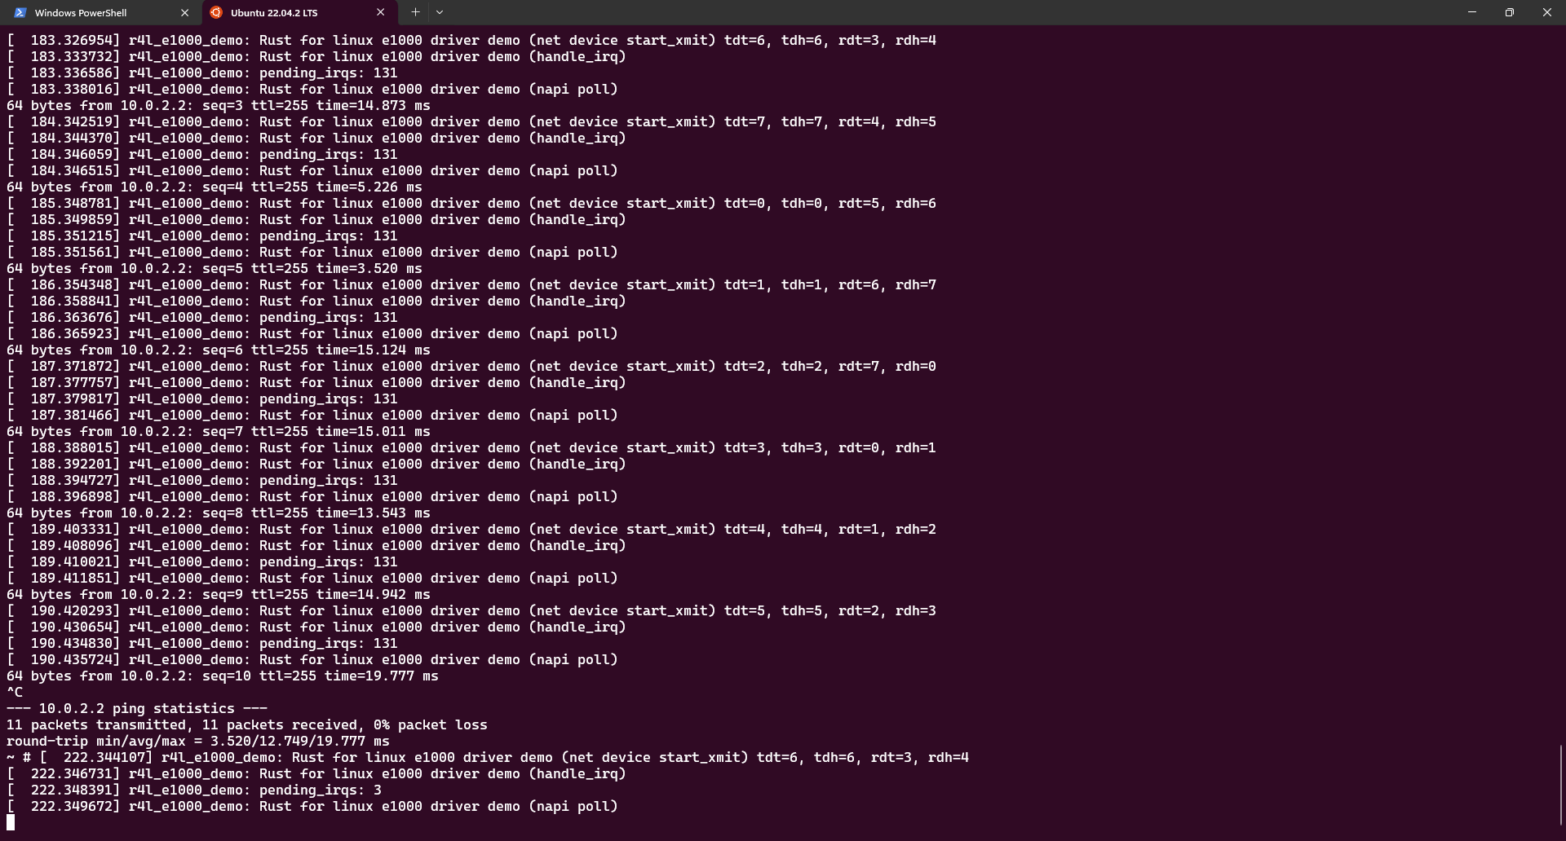

您可以看到该网卡驱动能够正常ping通网络。

**测试样例和分数说明：**

测试样例：

您在rust版本的网卡驱动中，使用ifconfig命令，将看不到任何网卡的信号，但是使用C版本，可以正常运行，看到网卡信号，并且使用ping命令，将正常链接网络，没有任何多余的打印输出。

1、  您需要在作业报告中，记录这些步骤和截图。

2、  您需要回答作业2开头提出的两个问题，根据您的理解回答即可，没有深度要求。

分数：本测试占20%的分数

**作业3：使用rust编写一个简单的内核模块并运行**

**作业说明：**

在上一份作业中，src_e1000网卡驱动使用了核外模块的方式进行编译，这次，我们将编译一个in-tree的简单的rust模块。

步骤如下：

1、  进入到Linux目录下samples/rust文件夹

2、  添加一个rust_helloworld.rs文件

3、  在该文件中添加如下内容

// SPDX-License-Identifier: GPL-2.0

//! Rust minimal sample.

use kernel::prelude::*;

module! {

  type: RustHelloWorld,

  name: "rust_helloworld",

  author: "whocare",

  description: "hello world module in rust",

  license: "GPL",

}

struct RustHelloWorld {}

impl kernel::Module for RustHelloWorld {

  fn init(_name: &'static CStr, _module: &'static ThisModule) -> Result<Self> {

      pr_info!("Hello World from Rust module");

Ok(RustHelloWorld {})

}

}

==》

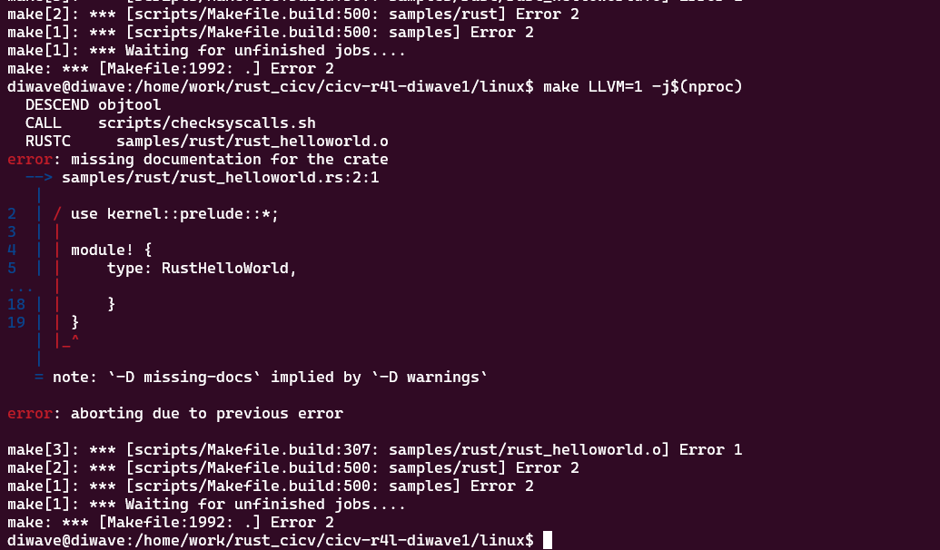

==》

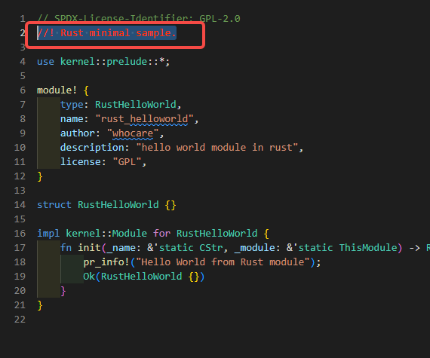

修改samples/rust下的Makefile和Kconfig

我们已经添加了rust_helloworld.rs源代码，但它还无法参与编译。请根据您学到的知识，在Kconfig和Makefile中添加适当的内容，使得：

1、  在menuconfig配置时，可以对该代码进行配置，选择是否编译，以及是否编译成模块；

2、  可以根据选择的配置，编译成功（编译进内核、或编译成模块）。

如果你添加的配置正确，那么可以运行

make LLVM=1 menuconfig

更改该模块的配置，使之编译成模块

Kernel hacking

---> Sample Kernel code

---> Rust samples

---> <M>Print Helloworld in Rust (NEW)

重新编译该内核，并运行src_e1000/build_image.sh

**测试样例和分数说明：**

测试样例：

如果一切正常，那么你将在samples/rust下看到一份rust_helloworld.ko的文件，将该文件复制到仓库中src_e1000/rootfs目录下，然后重新跑build_image.sh

==》需配置两个文件：

/home/work/rust_cicv/cicv-r4l-diwave1/linux/samples/rust/Kconfig

==》配置开关

/home/work/rust_cicv/cicv-r4l-diwave1/linux/samples/rust/Makefile

==> 需要编译的文件

==》

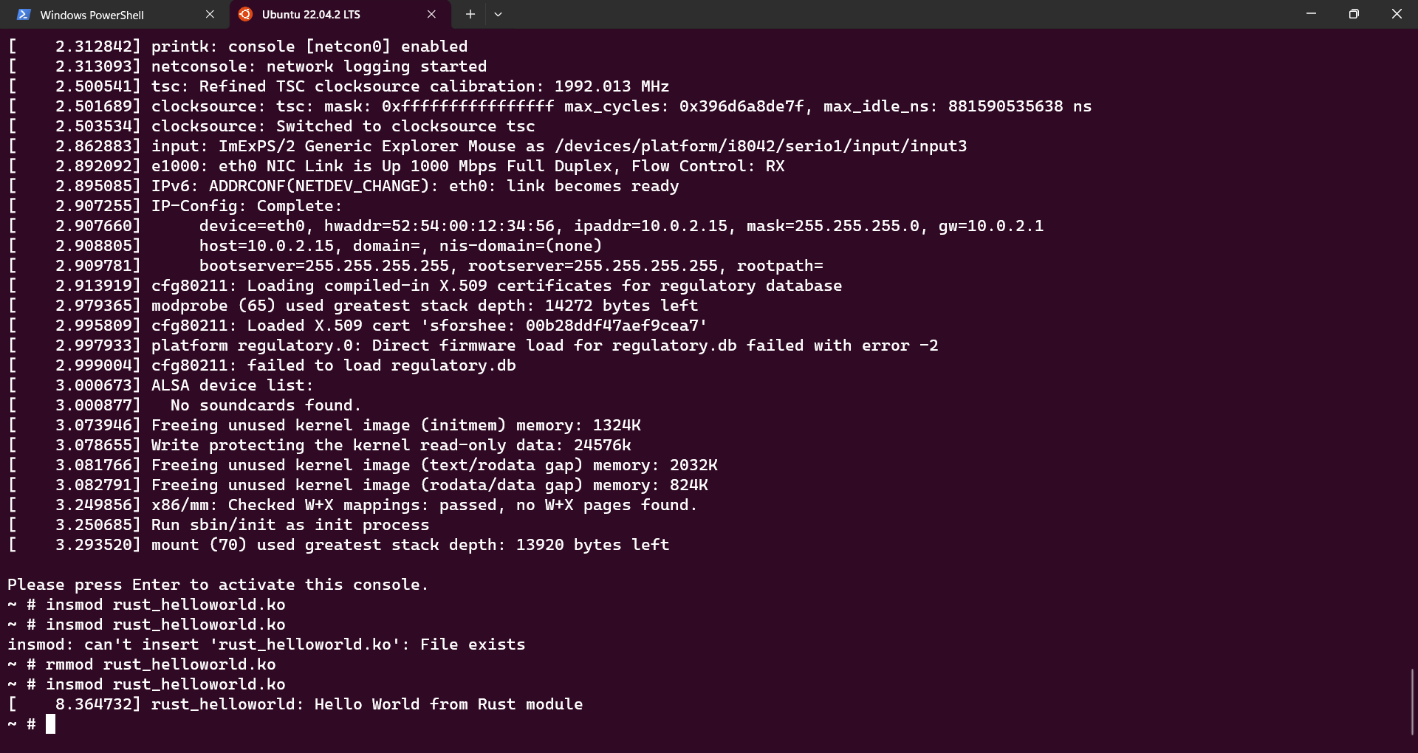

**==》已经找到原因，为什么第一次无法打印信息，需要卸载后，再挂载才能打印。是由于pr_info后面，需要增加“\n"**

随后在Linux shell下使用ls命令，你将发现一份新的rust_hellowrold.ko文件

使用insmod命令进行安装该模块

随后你将看到 "**Hello World from Rust module**"打印输出

1、  将上述过程记录在report中

2、  请在作业报告中记录您更新的Kconfig和Makefile

分数：本作业占20%分数

**作业4：为e1000网卡驱动添加remove代码**

**作业说明：**[linux-fujita + e1000 - r4l (thy1037.github.io)](https://thy1037.github.io/r4l-doc/rust_fujita_e1000.html#e1000-fujita)

正如前面所述，e1000网卡的代码仍有非常多不完善的地方。因此需要您加以完善。

在第一次训练营中，我们仅仅实现了stop函数，让他不再能够发包。和第一次训练营不同，这一次我们瞄准了remove函数，该函数的作用和insmod相反，会完全移除该内核模块。因此需要您清理对应的数据结构

需要您做的工作如下：

1、首先需要您将作业2中配置进行修改，禁用Linux内核原生的e1000网卡驱动。

2、其次，在src_e1000/r4l_e1000_demo.rs中有这样的函数

fn remove(data: &Self::Data) {

pr_info!("Rust for linux e1000 driver demo (remove)\n");

}

impl driver::DeviceRemoval for E1000DrvPrvData {

fn device_remove(&self) {

pr_info!("Rust for linux e1000 driver demo (device_remove)\n");

}

}

目前仅仅是一个打印输出而已，您需要在其中填充代码

注意，您可以参考C版本的e1000网卡的实现，但是请务必弄明白，并非所有C版本的代码都一定要实现一遍。同时，您也未必需要完全遵循demo代码给出的框架，您可以自由发挥，只需要按照测试样例正常跑过即可。

**测试样例和分数说明：**

测试样例：

需要参照作业2的配置方法，运行build_image.sh脚本之后，进入Linux环境下，随后按照作业2的方法进行配置并ping通。

之后使用

rmmod r4l_e1000_demo.ko

将该内核模块移除（即，您写的代码将被调用）

如果一切正常，那么重新按照作业2的方法，再次调用insmod命令，再一次安装该模块，能够正常ping通即可。

您需要在您的作业报告中提交关于这些的截图和内容

分数：本作业占20%分数

未对remove处理，挂载出错信息

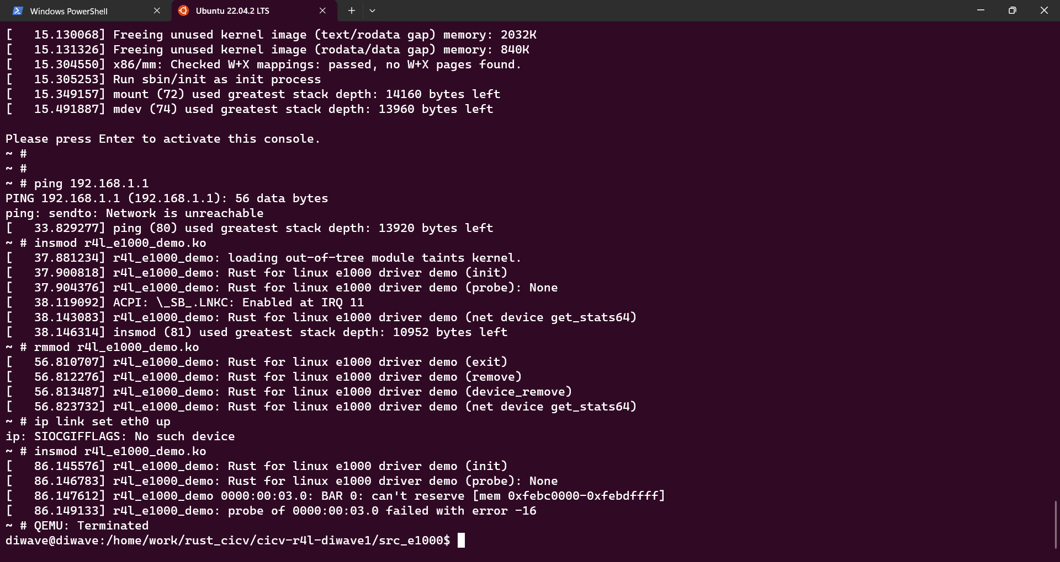

**作业5：注册字符设备**

**作业说明：**

这一次，我们回到Linux内核中，添加一个samples/rust/rust_chrdev.rs文件。

在我们给出的代码中的Linux系统中给出了一个 /dev/cicv 字符设备，但是没有绑定驱动

要求修改rust_chrdev.rs文件，往Linux系统中注册一个字符设备驱动，使得 /dev/cicv 可以完成基本的读写操作。

更改配置：

Kernel hacking

---> Sample Kernel code

---> Rust samples

---> <*>Character device (NEW)

参考资料：

[Rust for Linux | 用 Rust 写 Linux 内核模块-腾讯云开发者社区-腾讯云 (tencent.com)](https://cloud.tencent.com/developer/article/2189302)

[kernel - Rust (rust-for-linux.github.io)](https://rust-for-linux.github.io/docs/kernel/index.html)

    fn read(this: &Self,_file: &file::File,writer: &mut impl kernel::io_buffer::IoBufferWriter,offset:u64,) -> Result<usize> {

        let buf = &mut *this.inner.lock();

        //let buf: &mut [u8] = &mut *buf;

        pr_info!("RustFile read, offset: {}\n", offset);

        let offset = offset as usize;

        if offset > GLOBALMEM_SIZE {

            return Err(ENOMEM);

        }

        writer.write_slice(&buf[offset..])?;

        Ok(buf.len())

    }

**测试样例和分数说明：**

测试样例：

使用下列命令往字符设备写入内容

echo "Hello" > /dev/cicv

并使用下列命令读出写入的内容

cat /dev/cicv

成功后应该返回

Hello

直接编译后，不添加代码出错信息

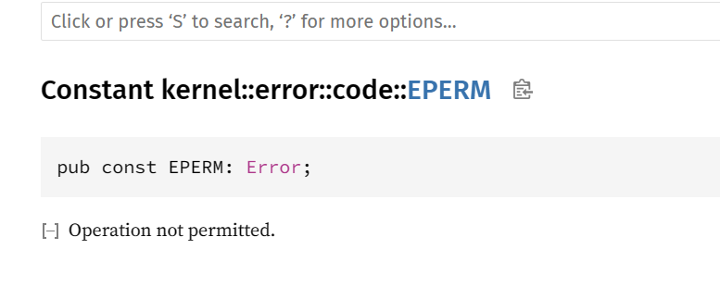

上文Rust-kernel错误链接：[kernel::error::code - Rust (rust-for-linux.github.io)](https://rust-for-linux.github.io/docs/kernel/error/code/index.html)

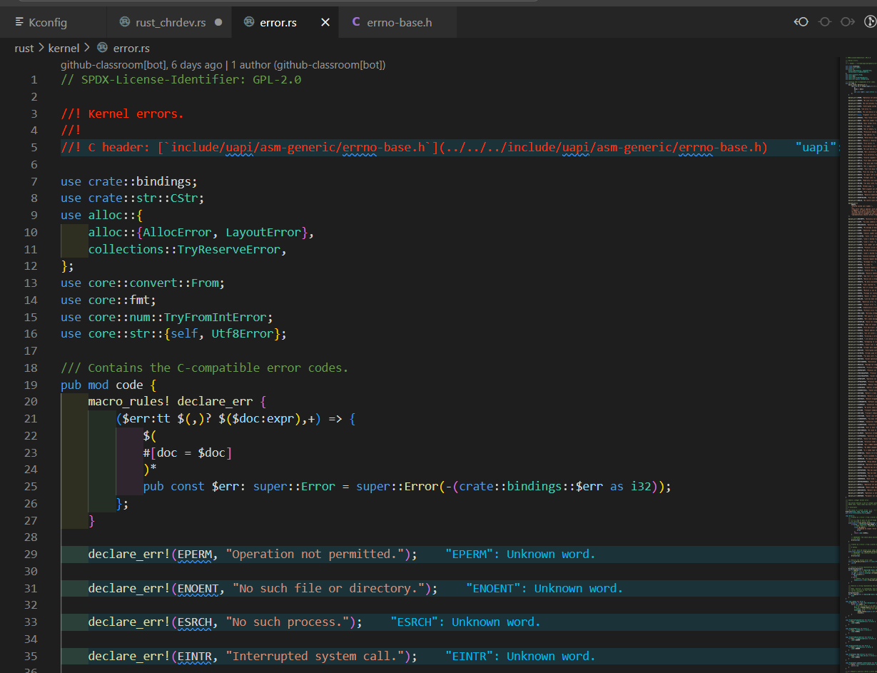

相对应C语言出错代码：[include/uapi/asm-generic/errno-base.h](https://rust-for-linux.github.io/include/uapi/asm-generic/errno-base.h)

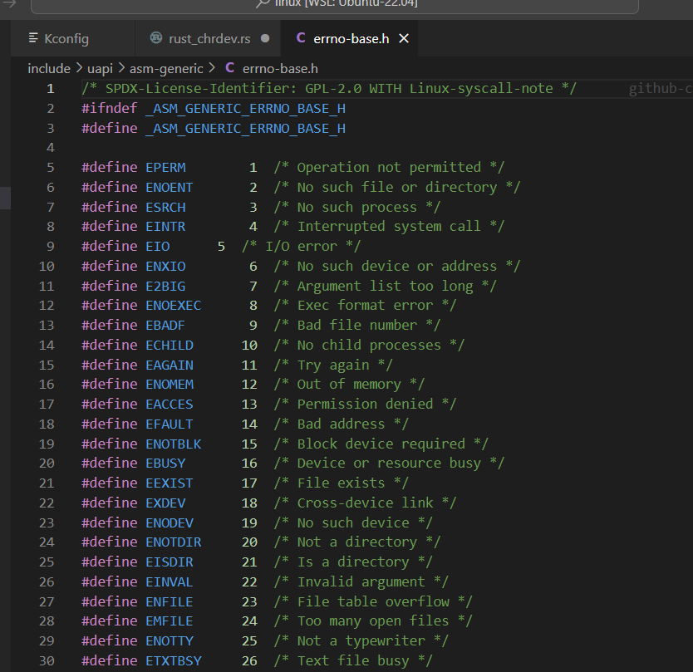

image.png

image.png

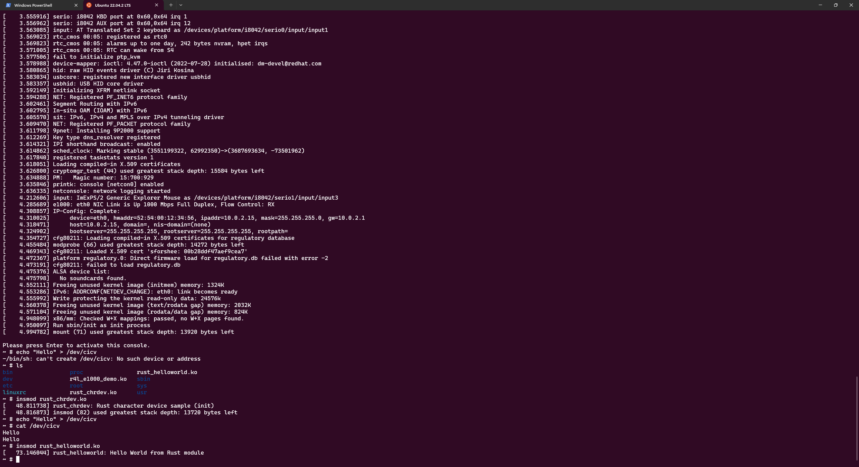

/home/work/rust_cicv/cicv-r4l-diwave1/linux/rust/kernel/file.rs

/// Corresponds to the kernel's `struct file_operations`.

///

/// You implement this trait whenever you would create a `struct file_operations`.

///

/// File descriptors may be used from multiple threads/processes concurrently, so your type must be

/// [`Sync`]. It must also be [`Send`] because [`Operations::release`] will be called from the

/// thread that decrements that associated file's refcount to zero.

#[vtable]

pub trait Operations {

    /// The type of the context data returned by [`Operations::open`] and made available to

    /// other methods.

    type Data: PointerWrapper + Send + Sync = ();

    /// The type of the context data passed to [`Operations::open`].

    type OpenData: Sync = ();

    /// Creates a new instance of this file.

    ///

    /// Corresponds to the `open` function pointer in `struct file_operations`.

    fn open(context: &Self::OpenData, file: &File) -> Result<Self::Data>;

    /// Cleans up after the last reference to the file goes away.

    ///

    /// Note that context data is moved, so it will be freed automatically unless the

    /// implementation moves it elsewhere.

    ///

    /// Corresponds to the `release` function pointer in `struct file_operations`.

    fn release(_data: Self::Data, _file: &File) {}

    /// Reads data from this file to the caller's buffer.

    ///

    /// Corresponds to the `read` and `read_iter` function pointers in `struct file_operations`.

    fn read(

        _data: <Self::Data as PointerWrapper>::Borrowed<'_>,

        _file: &File,

        _writer: &mut impl IoBufferWriter,

        _offset: u64,

    ) -> Result<usize> {

        Err(EINVAL)

    }

    /// Writes data from the caller's buffer to this file.

    ///

    /// Corresponds to the `write` and `write_iter` function pointers in `struct file_operations`.

    fn write(

        _data: <Self::Data as PointerWrapper>::Borrowed<'_>,

        _file: &File,

        _reader: &mut impl IoBufferReader,

        _offset: u64,

    ) -> Result<usize> {

        Err(EINVAL)

    }

    /// Changes the position of the file.

    ///

    /// Corresponds to the `llseek` function pointer in `struct file_operations`.

    fn seek(

        _data: <Self::Data as PointerWrapper>::Borrowed<'_>,

        _file: &File,

        _offset: SeekFrom,

    ) -> Result<u64> {

        Err(EINVAL)

    }

    /// Performs IO control operations that are specific to the file.

    ///

    /// Corresponds to the `unlocked_ioctl` function pointer in `struct file_operations`.

    fn ioctl(

        _data: <Self::Data as PointerWrapper>::Borrowed<'_>,

        _file: &File,

        _cmd: &mut IoctlCommand,

    ) -> Result<i32> {

        Err(ENOTTY)

    }

    /// Performs 32-bit IO control operations on that are specific to the file on 64-bit kernels.

    ///

    /// Corresponds to the `compat_ioctl` function pointer in `struct file_operations`.

    fn compat_ioctl(

        _data: <Self::Data as PointerWrapper>::Borrowed<'_>,

        _file: &File,

        _cmd: &mut IoctlCommand,

    ) -> Result<i32> {

        Err(ENOTTY)

    }

    /// Syncs pending changes to this file.

    ///

    /// Corresponds to the `fsync` function pointer in `struct file_operations`.

    fn fsync(

        _data: <Self::Data as PointerWrapper>::Borrowed<'_>,

        _file: &File,

        _start: u64,

        _end: u64,

        _datasync: bool,

    ) -> Result<u32> {

        Err(EINVAL)

    }

    /// Maps areas of the caller's virtual memory with device/file memory.

    ///

    /// Corresponds to the `mmap` function pointer in `struct file_operations`.

    fn mmap(

        _data: <Self::Data as PointerWrapper>::Borrowed<'_>,

        _file: &File,

        _vma: &mut mm::virt::Area,

    ) -> Result {

        Err(EINVAL)

    }

    /// Checks the state of the file and optionally registers for notification when the state

    /// changes.

    ///

    /// Corresponds to the `poll` function pointer in `struct file_operations`.

    fn poll(

        _data: <Self::Data as PointerWrapper>::Borrowed<'_>,

        _file: &File,

        _table: &PollTable,

    ) -> Result<u32> {

        Ok(bindings::POLLIN | bindings::POLLOUT | bindings::POLLRDNORM | bindings::POLLWRNORM)

    }

}

留下一个问题：

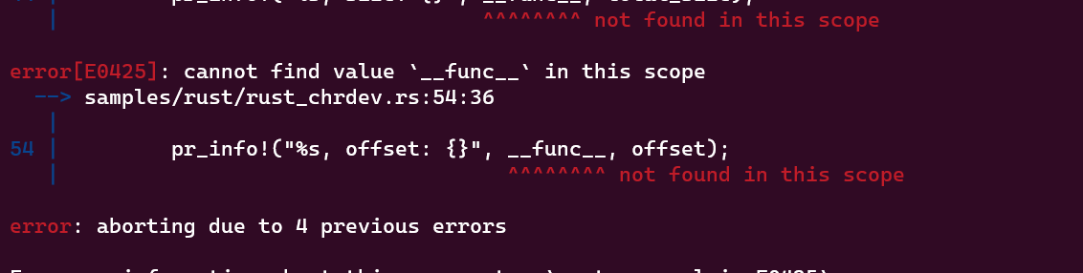

const GLOBALMEM_SIZE: usize = 0x10;

出现内存溢出

Please press Enter to activate this console.

~ # insmod rust_chrdev.ko

[ 12.519592] rust_chrdev: Rust character device sample (init)

[ 12.522700] insmod (78) used greatest stack depth: 13864 bytes left

~ # echo "123456789012345678" > /dev/cicv

[ 29.037748] rust_chrdev: RustFile open

[ 29.040397] rust_chrdev: RustFile write, size: 19

[ 29.042650] rust_kernel: panicked at 'range end index 19 out of range for slice of length 16', /home/diwave/.rustup/toolchains/1.62.0-x86_645

[ 29.045773] ------------[ cut here ]------------

[ 29.046178] kernel BUG at rust/helpers.c:47!

[ 29.048185] invalid opcode: 0000 [#1] PREEMPT SMP NOPTI

[ 29.050577] CPU: 0 PID: 74 Comm: sh Not tainted 6.1.0-rc1 #9

[ 29.051280] Hardware name: QEMU Standard PC (i440FX + PIIX, 1996), BIOS rel-1.16.1-0-g3208b098f51a-prebuilt.qemu.org 04/01/2014

[ 29.052807] RIP: 0010:rust_helper_BUG+0x0/0x10

[ 29.054350] Code: c6 b0 48 c7 44 24 30 00 00 00 00 48 8d 7c 24 08 48 c7 c6 b0 c6 c6 b0 e8 be 41 88 00 0f 0b 00 00 cc cc 00 00 cc cc 00 00 cc6

[ 29.057092] RSP: 0018:ffff9d59001c7cc0 EFLAGS: 00000286

[ 29.057942] RAX: 00000000000000cc RBX: ffff986d42417a00 RCX: 0000000000000001

[ 29.059656] RDX: 0000000000000000 RSI: 0000000000000004 RDI: 00000000ffffffff

[ 29.060642] RBP: ffff986d42417a68 R08: 0000000000000000 R09: ffffffffb1281880

[ 29.061931] R10: 0000000000000000 R11: 00000000ffffdfff R12: 0000000000b620a0

[ 29.063207] R13: 0000000000000013 R14: ffff9d59001c7ef0 R15: ffffffffc01f0000

[ 29.063859] FS: 0000000000b543c0(0000) GS:ffff986d47800000(0000) knlGS:0000000000000000

[ 29.064956] CS: 0010 DS: 0000 ES: 0000 CR0: 0000000080050033

[ 29.066137] CR2: 00000000005caed0 CR3: 000000000247c000 CR4: 00000000000006f0

[ 29.067825] Call Trace:

[ 29.069629] <TASK>

[ 29.070029] rust_begin_unwind+0x66/0x80

[ 29.070824] ? _RNvXsP_NtCs3yuwAp0waWO_4core3fmtRhNtB5_5Debug3fmtCsfATHBUcknU9_6kernel+0x50/0x50

[ 29.071830] ? _RNvNtCs3yuwAp0waWO_4core9panicking9panic_fmt+0x2c/0x30

[ 29.073312] ? _RNvNtNtCs3yuwAp0waWO_4core5slice5index27slice_end_index_len_fail_rt+0x73/0x80

[ 29.074342] ? _RNvXs4_NtNtNtCs3yuwAp0waWO_4core3fmt3num3impxNtB9_7Display3fmt+0x20/0x20

[ 29.075268] ? _RNvXs4_NtNtNtCs3yuwAp0waWO_4core3fmt3num3impxNtB9_7Display3fmt+0x20/0x20

[ 29.076223] ? _RNvYNvNtNtCs3yuwAp0waWO_4core5slice5index27slice_end_index_len_fail_rtINtNtNtB8_3ops8function6FnOnceTjjEE9call_onceB8_+0x6/00

[ 29.078900] ? _RINvNtCs3yuwAp0waWO_4core10intrinsics17const_eval_selectTjjENvNtNtB4_5slice5index27slice_end_index_len_fail_ctNvBY_27slice_e0

[ 29.080544] ? _RNvNtNtCs3yuwAp0waWO_4core5slice5index24slice_end_index_len_fail+0x6/0x10

[ 29.081957] ? _RNvMs3_NtCsfATHBUcknU9_6kernel4fileINtB5_16OperationsVtableINtNtB7_6chrdev12RegistrationKj2_ENtCsbz7zR1RBgyO_11rust_chrdev8R]

[ 29.086709] ? _RNvXs4_NtNtNtCs3yuwAp0waWO_4core3fmt3num3impxNtB9_7Display3fmt+0x20/0x20

[ 29.087663] ? vfs_write+0x124/0x380

[ 29.087885] ? handle_mm_fault+0x69/0x160

[ 29.088251] ? ksys_write+0x50/0xa0

[ 29.088869] ? do_syscall_64+0x43/0x90

[ 29.089436] ? entry_SYSCALL_64_after_hwframe+0x63/0xcd

[ 29.090221] </TASK>

[ 29.090491] Modules linked in: rust_chrdev

[ 29.091985] ---[ end trace 0000000000000000 ]---

[ 29.093403] RIP: 0010:rust_helper_BUG+0x0/0x10

[ 29.093822] Code: c6 b0 48 c7 44 24 30 00 00 00 00 48 8d 7c 24 08 48 c7 c6 b0 c6 c6 b0 e8 be 41 88 00 0f 0b 00 00 cc cc 00 00 cc cc 00 00 cc6

[ 29.096830] RSP: 0018:ffff9d59001c7cc0 EFLAGS: 00000286

[ 29.098035] RAX: 00000000000000cc RBX: ffff986d42417a00 RCX: 0000000000000001

[ 29.101106] RDX: 0000000000000000 RSI: 0000000000000004 RDI: 00000000ffffffff

[ 29.102857] RBP: ffff986d42417a68 R08: 0000000000000000 R09: ffffffffb1281880

[ 29.104449] R10: 0000000000000000 R11: 00000000ffffdfff R12: 0000000000b620a0

[ 29.106316] R13: 0000000000000013 R14: ffff9d59001c7ef0 R15: ffffffffc01f0000

[ 29.107163] FS: 0000000000b543c0(0000) GS:ffff986d47800000(0000) knlGS:0000000000000000

[ 29.108487] CS: 0010 DS: 0000 ES: 0000 CR0: 0000000080050033

[ 29.109828] CR2: 00000000005caed0 CR3: 000000000247c000 CR4: 00000000000006f0

[ 29.119667] sh (74) used greatest stack depth: 13232 bytes left

Please press Enter to activate this console.

需要在write对输入数据大小作判断

    fn write(this: &Self,_file: &file::File,reader: &mut impl kernel::io_buffer::IoBufferReader,_offset:u64,) -> Result<usize> {

        let total_size  = reader.len();

        pr_info!("RustFile write, size: {}\n", total_size);

        if total_size > GLOBALMEM_SIZE {

            return Err(ENOMEM);

        }

        let buf = &mut this.inner.lock();

        reader.read_slice(&mut buf[..total_size])?;

        Ok(total_size)

    }

==》

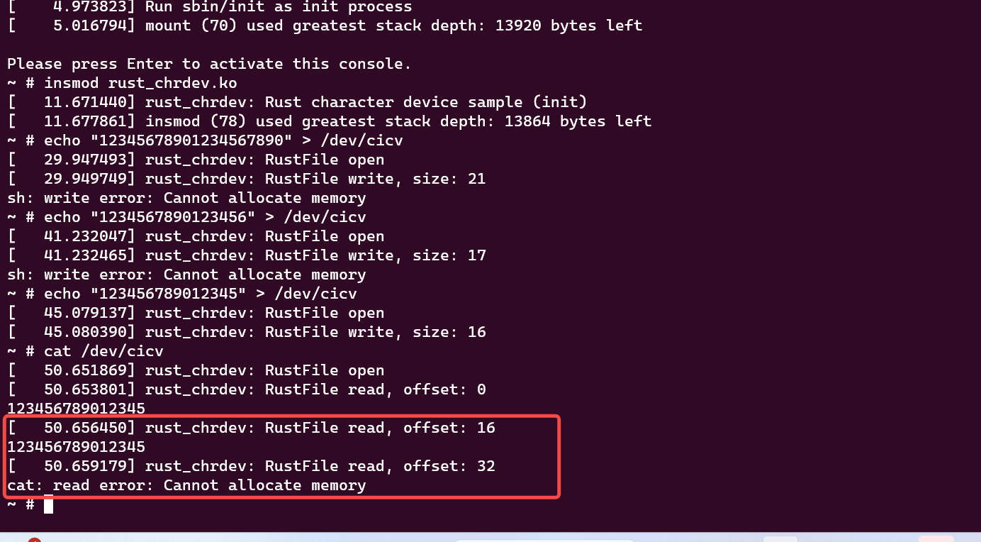

出现一个问题，cat时，出现 offset还在输出数据。

修改

    fn read(this: &Self,_file: &file::File,writer: &mut impl kernel::io_buffer::IoBufferWriter,offset:u64,) -> Result<usize> {

        let buf = &mut *this.inner.lock();

        pr_info!("RustFile read, offset: {}\n", offset);

        let offset = offset as usize;

        if offset >= GLOBALMEM_SIZE {

            return Err(ENOMEM);

        }

        writer.write_slice(&buf[offset..])?;

        Ok(buf.len())

    }

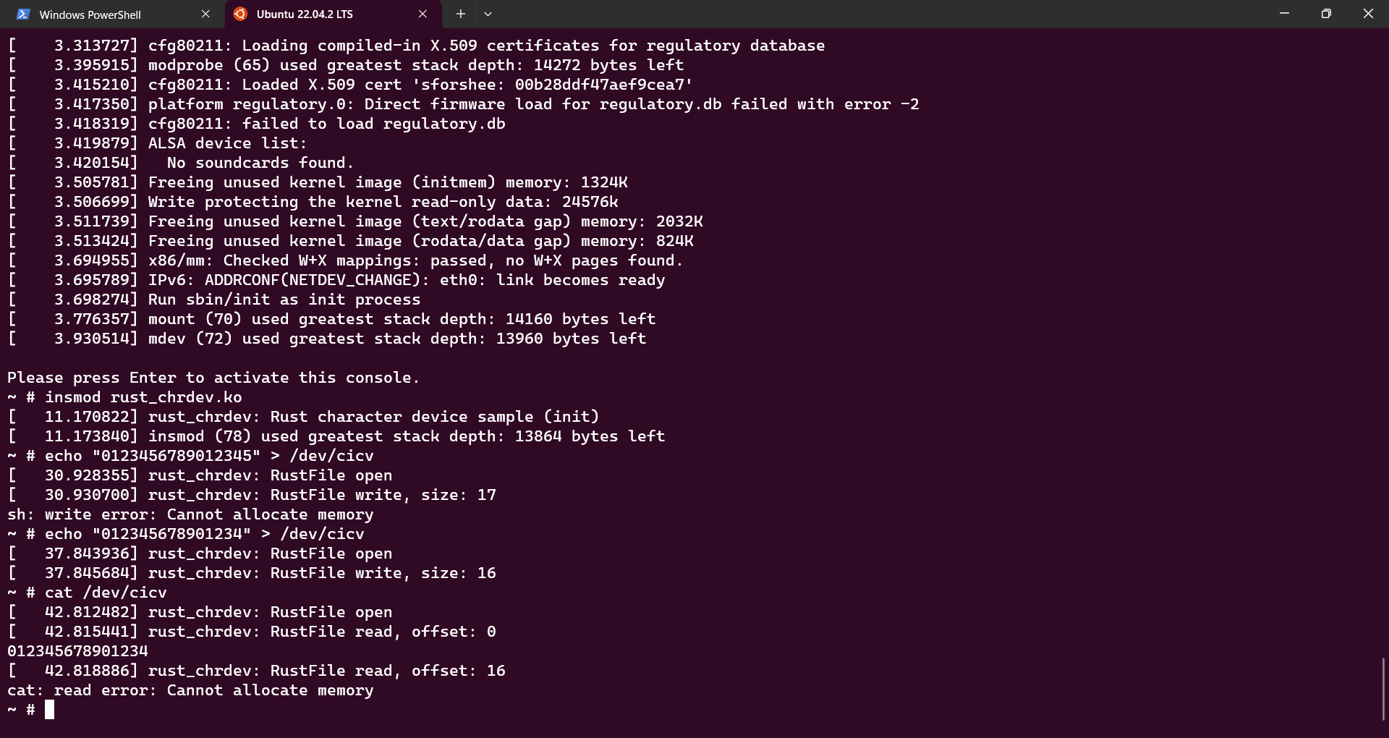

/dev/cicv的绑定方式，在启动时，

echo "mknod /dev/cicv c 248 0" >> etc/init.d/rcS

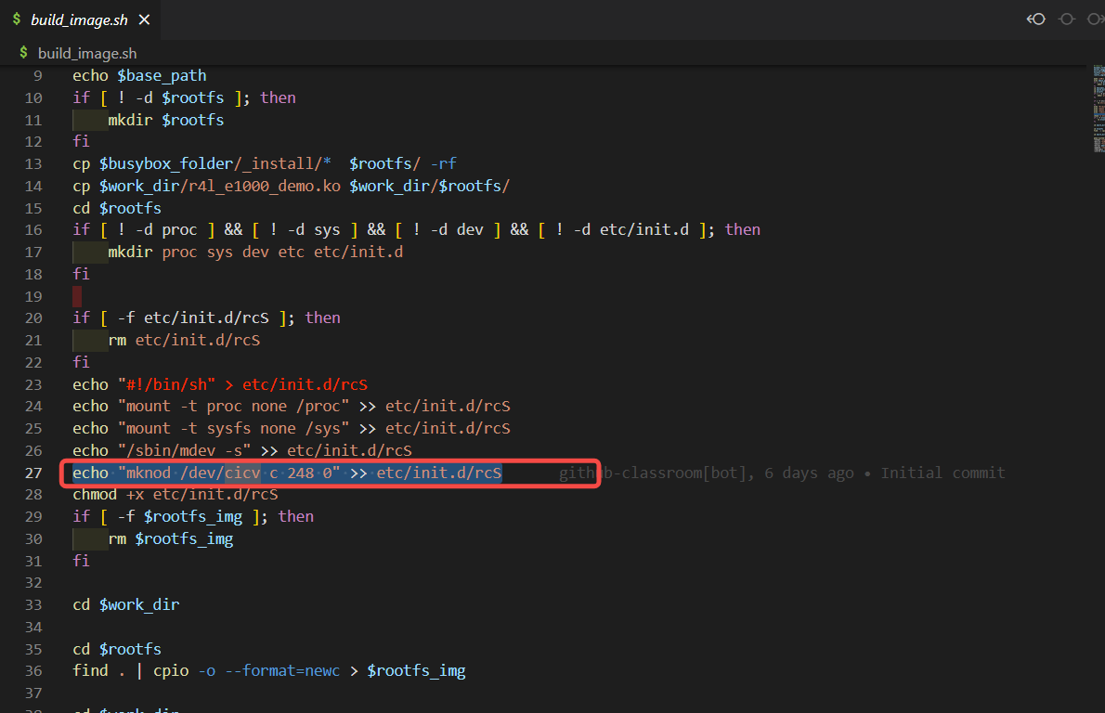

[linux mknod命令解析-CSDN博客](https://blog.csdn.net/a1010256340/article/details/83088870)

您需要在您的作业报告中提交关于这部分的内容

分数：本作业占20%分数

**关于提交作业报告**

您需要按照上述的作业要求，写一份作业报告，并放在您的仓库中，最后在下面的表格中进行登记

[cicv第二阶段rust for Linux作业完成记录登记表](https://docs.qq.com/sheet/DY1ZYVm9WQW16a05z?tab=BB08J2)